|  |  |  |
| --- | --- | --- |
| *compounds*  CλeMis+ry [eagenest@madison.k12.wi.us](mailto:eagenest@madison.k12.wi.us) |  | Name_____________________  Period____________________ |

1. Into the blanks below write the following words (use each word or phrase only once): *Mixtures, Mixtures of Compounds, Mixtures of Elements, All Matter, Substances, Compounds, Elements, Mixtures*

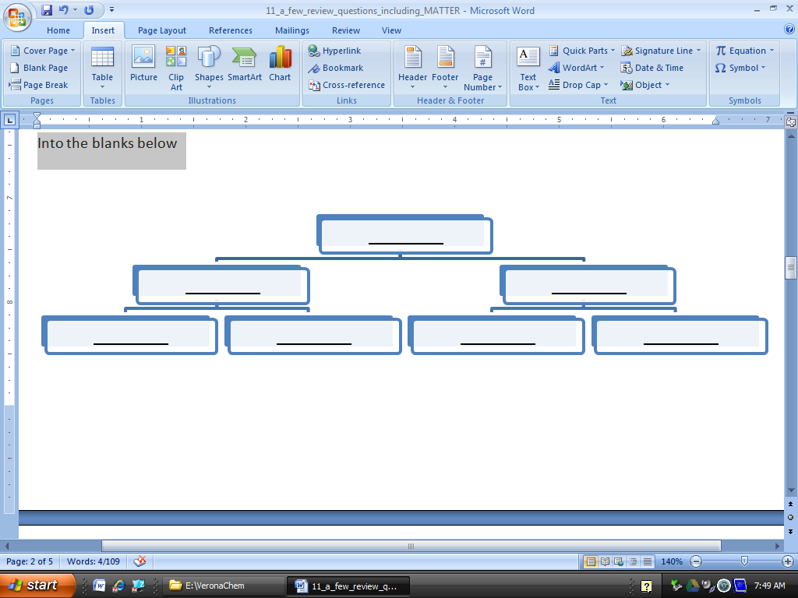

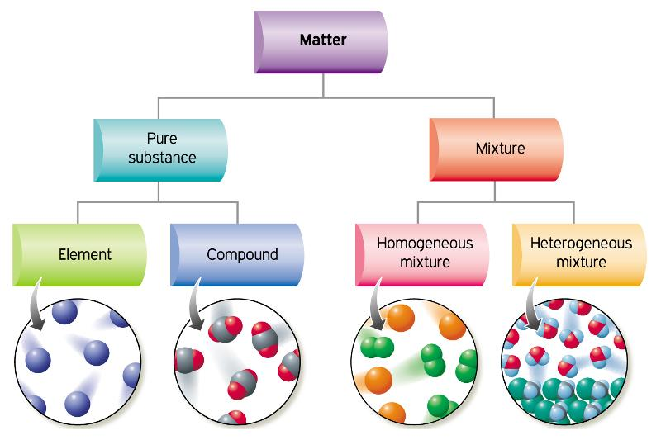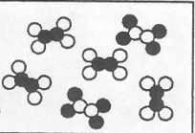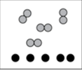

1. If a small crumb of aspirin has a mass of 0.5405 grams and contains 0.3243g of carbon, 0.0242g of hydrogen, and 0.192g of oxygen, calculate
   1. the percent of oxygen in aspirin:
   2. the percent of carbon in aspirin:
2. Orange Compound: 25.0 g of Cl / 44.0 g of Fe

Red Compound: 58.6 g of Cl / 34.4 g of Fe

* 1. .Determine the ratio  in each compound. Orange ____ Red ____
  2. Which is Fe1Cl1? __________________
  3. What is the formula of the other compound? ____________________

1. **Data from a lab.**

**Compound SWEET: 88.8 grams X 67.2 grams Y**

**Compound BITTER: : 79.9 grams X 20.1 grams Y**

* 1. Determine the ratio $\frac{X grams}{Y grams}$ in each compound. SWEET ____ BITTER ____
  2. Which is X1Yl1? __________________
  3. What is the formula of the other compound? ____________________

1. Make a chart of every possible type of thing.
2. 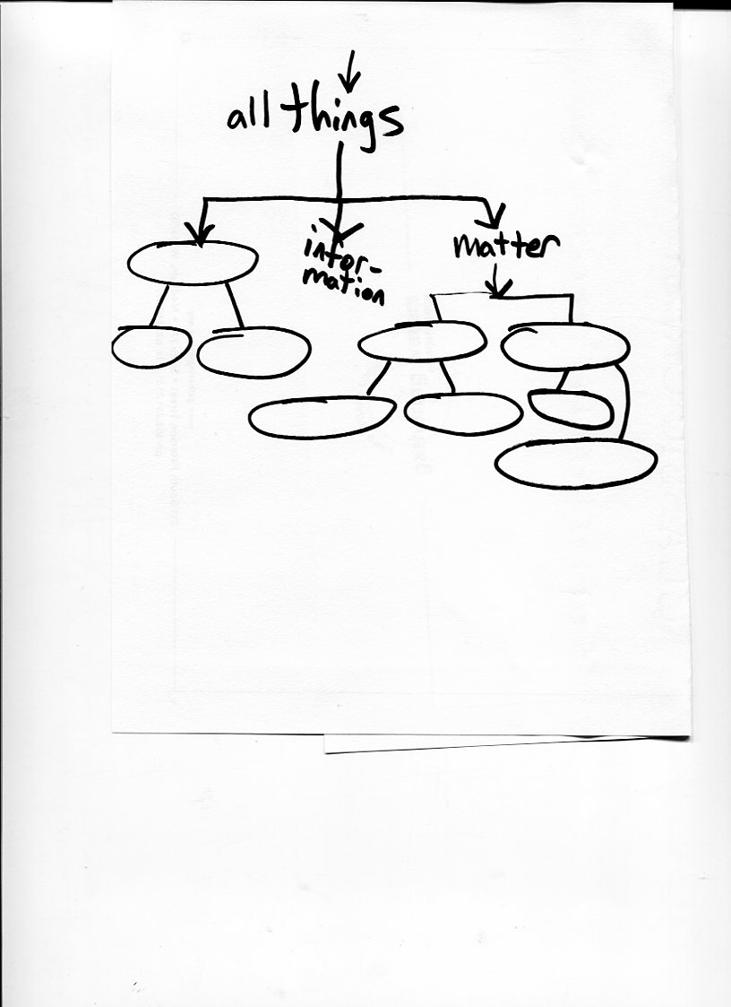

|  |
| --- |
| For each mixture separation below, choose which property each separation relies on.  For your answer in each question write one of theseproperties:  (BP) different boiling points (S) different solubilities (MP) different melting points  (D) different densities |

1. __________Ethanol can be separated from water by distillation
2. __________Uranium 235 can be separated from harmless Uranium 238 by spinning it in a centrifuge
3. __________Mountain Dew will be sweeter if you freeze it and remove the ice crystals that form .
4. __________ Muddy salt water can be made transparent by pouring it through a filter.

|  |  |  |
| --- | --- | --- |
| Make a particle picture in each box. . Follow Avogadro’s Hypothesis: make double sized boxes contain double the number of particles. The first box has been done for you | Draw five particles that are a mixture of elements | Draw a compound |
| Draw a mixture of compounds | Draw a substance that is not a compound.  (Remember Avogadro!) | |

|  |  |  |
| --- | --- | --- |
| Mark the best description of this box:  □ a substance  □a mix of substances |  | Mark the best description of this box:  □ contains compounds  □contains elements  □ contains compounds and elements |

|  |  |  |
| --- | --- | --- |
| Mark the best description of this box:  □ a substance  □a mix of substances |  | Mark the best description of this box:  □ contains compounds  □contains elements  □ contains compounds and elements |

1. What is Avogadro's hypothesis?

___________________________________________________________________________

___________________________________________________________________________

1. This picture represents the before and after of a chemical change. Everything shown is at the same pressure, temperature, and volume. Inside the balloons on the right draw an appropriate number of molecules that could form and make the balloons this size.

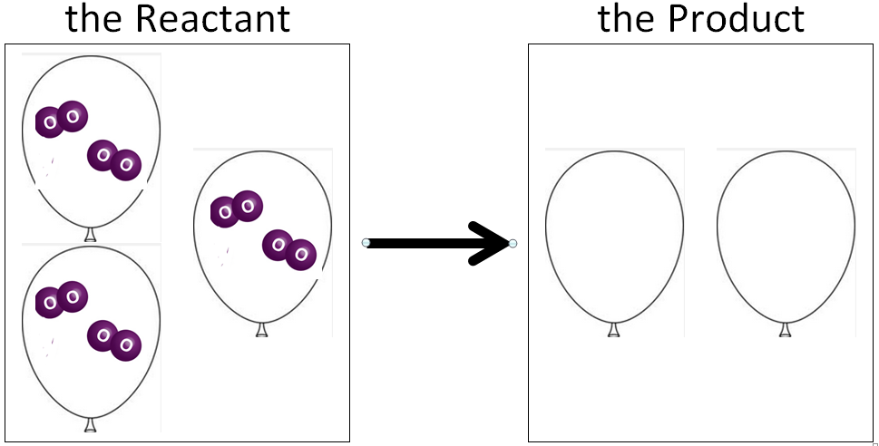

|  |  |
| --- | --- |
|  | 1. Could this method separate the hydrogen from oxygen in H2O?   yes / no   1. Could this method separate salt from water in ocean water?   yes / no     1. Above is the label from a Gatorade bottle.   Is Gatorade a substance, mixture, or element?  ______________________________   1. If Gatorade were placed at position A, how many substances would later appear at B?   ( 0 / 1 / 2 / 3 / 4 / 5 )   1. k |

|  |  |
| --- | --- |
| assume the liquid shown inside the glassware is all H2O | 1. Could this method separate the hydrogen from oxygen in H2O?   yes / no   1. In this case, a _________ is being separated into ________    1. element, mixture    2. mixture, elements    3. substance, elements    4. mixture, substances 2. Look carefully at the amount of gas in each side. Which side is collecting the hydrogen from H2O    1. Side A    2. Side B |

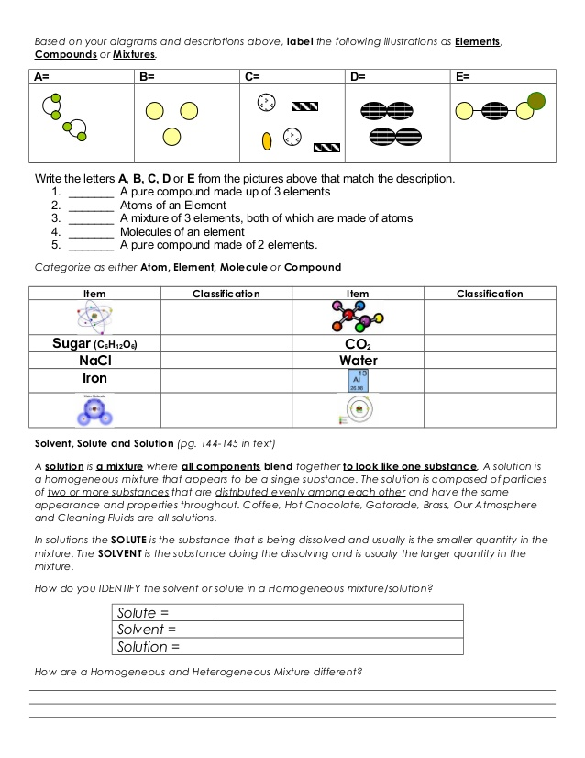

|  |  |
| --- | --- |
|  | 1. Could this method separate the hydrogen from oxygen in H2O?   yes / no   1. Could this method separate salt from water in ocean water?   yes / no     1. Above is the label from a Gatorade bottle.   Is Gatorade a substance, mixture, or element?  ______________________________   1. If Gatorade were placed at position C, how many substances would later appear at E?   ( 0 / 1 / 2 / 3 / 4 / 5 )   1. In this case, a _________ is being separated into ________    1. element, mixture    2. mixture, elements    3. substance, elements    4. mixture, substances |

Complete the diagram with the following words: salt(NaCl), matter, mixture, iron(Fe), homogeneous, substance, Snickers® , air, heterogeneous, compound, element

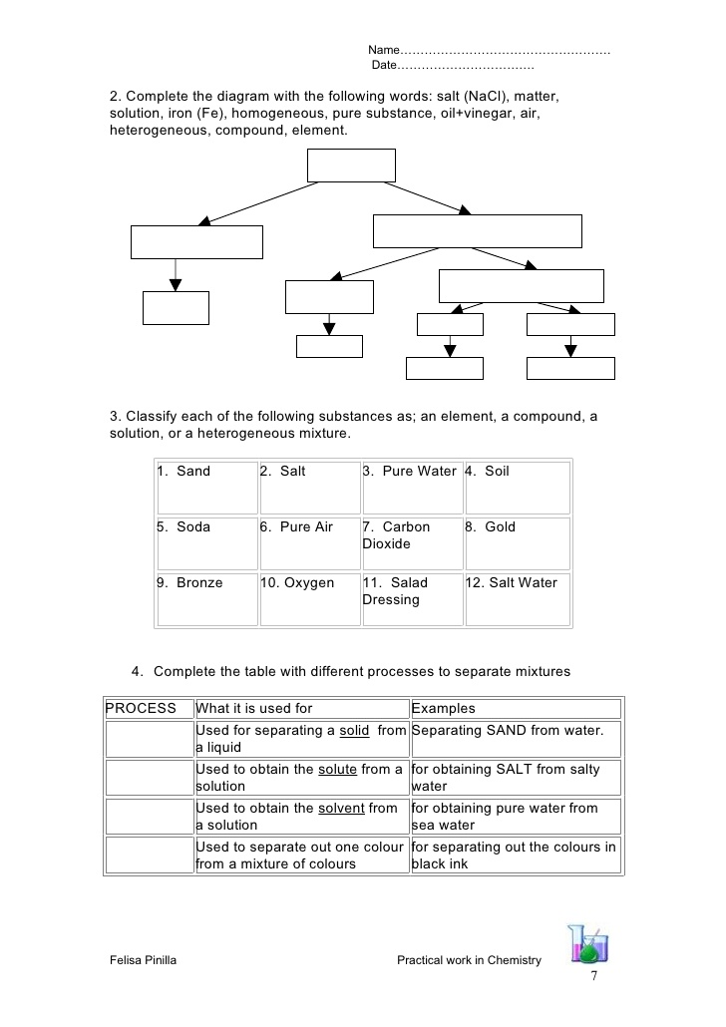

|  |  |  |
| --- | --- | --- |
| Process | Used for | Examples |
|  | Used for separating a liquid from a solid | Separating sand from water |
|  | Used to obtain a liquid from a homogeneous mixture (or solution) | for obtaining pure water from sea water |
|  | Used to separate out one color from a mixture of colors | for separating out the colors in ink |
|  | For separating out a heavier substance from a lighter one | moving Uranium 238 away from Uranium 235 |