Review #2, less math  East.H.S. ©λ€M|5+rγ  visit http://genest.weebly.com | 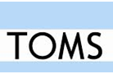 | Name_________________  Date__________________  The test is Friday. What’s on it?  See the class website.

Will the test just look like these problems? No! It can have anything we learned. Everything we learn is important.
Review the original notes and worksheets.

- Write the seven elements that usually form diatomic molecules when they are not in a compound:

________________________________________________________________________________

- Sketch a particle diagram representing a mixture of hydrogen and oxygen gases. Sketch a particle diagram for the compound formed when these gases react.
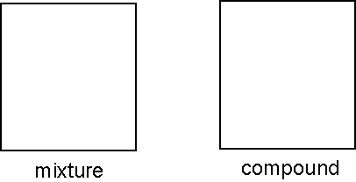

- Write 'intrinsic' next to any property that is intrinsic.

- color
- mass
- density
- shape
- melting point
- magnetic (ability to be attracted to a magnet)

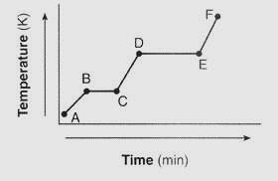  - Write start and write stop to indicate what will happen to hot iron when you drop it in cold water | - Write start and write stop to indicate what will happen cold water when hot metal is dropped into it.

- Decide whether heating (we called it Q) is entering or leaving the object in bold..
a) An ice cube is placed in a cup of hot coffee
An ice cube is placed in a cup of hot coffee
b) A pot of hot tea is sealed into a well-insulated thermos
c) Some cold cream is poured into a cup of hot coffee
d) You blow air across a bowl of hot soup
e) You jump into an ice cold pond
For each item below indicate whether it applies to HEAT or TEMPERATURE
- _____ Can be measured by inserting a thermometer
- _____ Can be measured by holding water nearby and then multiplying mass_{water} x Cp_{water} x ΔT_{water}

- _____ one common unit for measuring this is degrees celsius
- _____ one common unit for measuring this is kelvins
- _____ one common unit for measuring this is joules

- Check the appropriate box to describe each box’s contents
Mark the best description of this box:  □ a substance  □a mix of substances | 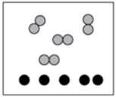 | Mark the best description of this box:  □ contains compounds  □contains elements  □ contains compounds and elements

Mark the best description of this box:  □ a substance  □a mix of substances | 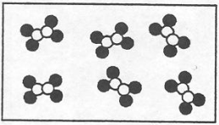 | Mark the best description of this box:  □ contains compounds  □contains elements  □ contains compounds and elements

- What is Avogadro's principle?
___________________________________________________________________________

___________________________________________________________________________

- What is Proust's Law?
___________________________________________________________________________

___________________________________________________________________________

Next to each write physical change or chemical to indicate which type of change is being described.

- If a mixture of these three metals is heated, circle which substance will melt first (based on their melting point (mp):
magnesium Lutetium Lithium
- If crushed and placed in foaming water which substance would sink fastest (based on their specific gravity):
magnesium Lutetium Lithium
- If a mixture of these three metals were heated until it was completely liquid and then allowed to cool, circle which substance would freeze (become solid) first (based on their melting point (mp):
magnesium Lutetium Lithium
- If crushed and placed in foaming water which substance would float the best on the surface (based on their specific gravity):
magnesium Lutetium Lithium
- If heated until they were a gas, which substance would vaporize first? (based on the boiling point):
magnesium Lutetium Lithium

Show work for full credit.

- If 15 grams of metal were dropped into 11 grams of water calculate the following
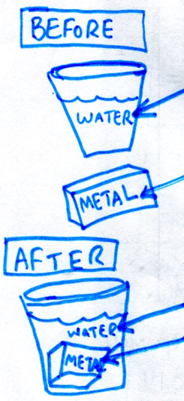 | 14°C water  101°C metal  43°C water  43°C metal | - Find ∆T for the water.  - How many joules of heat entered the water?  - How many joules of heat heat left the metal?
- Calculate the specific heat of the metal

- Consider the four containers below.
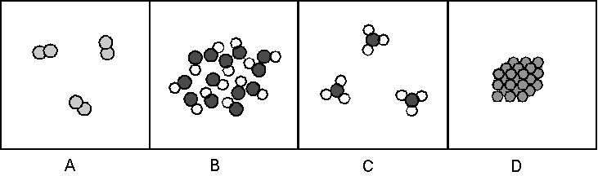
a. Which of these are mixtures? pure substances?

b. Which contain only compounds? only elements

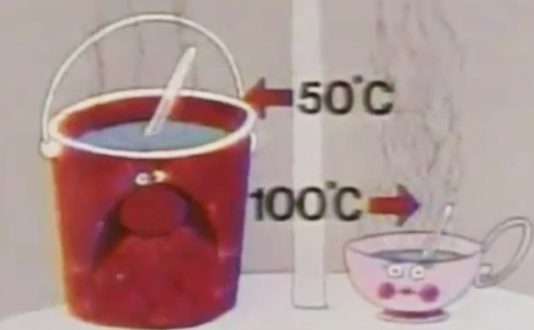
- Which has faster average vibration speed, water in the bucket on the left or water in the teacup on the right?

- Which has more joules, water in the bucket on the left or water in the teacup on the right?

