substance or mixture?  E.H.S. ©λ#M!$+rγ  Mr. Genest |  | Name_________________  Date__________________  Tutors! Adults! Help this young chemist by visiting http:genest.weebly.com with any smart phone

We think this stuff is | Name of stuff | If you said it's a mix, what's it a mix of?
□ a substance  □a mix of substances | a hot serving of Cinnamon-Raisin Oatmeal
□ a substance  □a mix of substances | Plain hot oatmeal
□ a substance  □a mix of substances | a sheet of aluminum foil
□ a substance  □a mix of substances | Snickers®
□ a substance  □a mix of substances | steam
□ a substance  □a mix of substances | an iron frying pan
□ a substance  □a mix of substances | hot tea (after you take the tea bag out)
□ a substance  □a mix of substances | an apple
□ a substance  □a mix of substances | Pepsi®
□ a substance  □a mix of substances | water with sugar dissolved in it
□ a substance  □a mix of substances | very smooth peanut butter

We think this stuff is | Picture of stuff | If you said it's a mix, what's it a mix of? (draw one of each type of particle)
□ a substance  □a mix of substances | 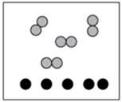
□ a substance  □a mix of substances | 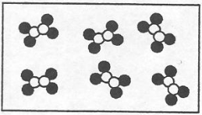
□ a substance  □a mix of substances | 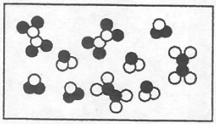
□ a substance
□a mix of substances
□ a substance  □a mix of substances | 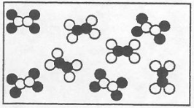
□ a substance  □a mix of substances | 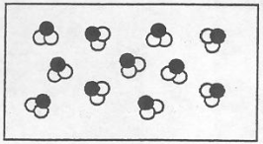
□ a substance  □a mix of substances | 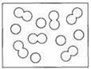
□ a substance
□a mix of substances

classwork

- Specific gravity is another name for ___________________________
- Density test: The more a Sp Gr exceeds 1.00 the faster an object sinks in water.
- In the paragraphs, highlight or circle each mp, bp, and sp. gr.

- If a mixture of these three metals is heated, circle which substance will melt first (based on their melting point (mp):
magnesium Lutetium
- If crushed and placed in foaming water which substance would sink fastest (based on their specific gravity):
Lutetium Lithium
- If a mixture of these three metals was heated until it was completely liquid and then allowed to cool, circle which substance will freeze (become solid) first (based on their melting point (mp):
magnesium Lithium
- If crushed and placed in foaming water which substance would float the best on the surface (based on their specific gravity):
Lutetium Lithium
- If heated until they were a gas, which substance would stay liquid the longest before turning into a gas (based on their boiling points):
magnesium Lithium
- If heated until they were a gas, and then allowed to cool to a liquid, which substance would become liquid first (based on their boiling points):
Lutetium Lithium

- The following data is for an experiment where metal was heated and then dropped into water. The thermometers show several useful temperatures. The graduated cylinder shows the volume of the water. Calculate answers to the two questions.
How much heat (in joules) entered the water?  How much heat left the metal? | 