will the separation work?  E.H.S. ©λ#M!$+rγ  Mr. Genest |  | Name_________________  Date__________________  Tutors! Adults! Help this young chemist by visiting http:genest.weebly.com with any smart phone
- Classify each mixture as heterogeneous or homogeneous

  - _________________ gasoline
  - _________________ milk
  - _________________ blood
  - _________________ chocolate chip ice cream
  - _________________ brass (a blend of copper and zinc)
  - _________________ black coffee

- Which box would only give one substance if you distilled it?  - Box A  - Box B  - Box C |  | 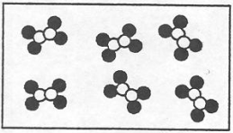 | 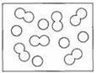 | 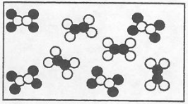
 |  | A | B | C

- Under each image write a separation technique:  - distillation  - chromatography  - filtration  - partial freezing  - partial melting  - diffusion |  | 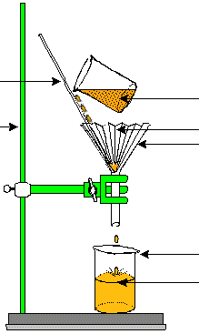 | 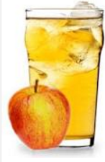 | 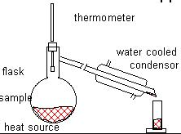
 |  | This separation process is: _______________ | This is separated using: _______________ | This separation process is: _______________

Match the separation method with the physical principal  - ______ Filtering a mixture of water, sand , and sugar  - ______ Distilling a mixture of water and ethanol  - ______ Centrifuging a mixture of Uranium 235 and Uranium 238  - ______ Heating a rock over a campfire until the metal called lead comes out of the rock.  - ______ Crushing iron ore rocks and collecting the iron that sinks to the bottom of a tank of soapy water while the sand and silica floats to the top |  | - different melting points  - different boiling points  - different solubility (dissolves differently  - different mass or density
- If a 14.1g disc made of unknown metal is heated using 349 joules, its temperature rises 3.79°C. Calculate the specific heat of the disc.

- If you used distillation to separate a mixture of decane and hexane, which would distill first?  - Distillation works because two substances have different  - melting points  - boiling points  - densities  - If you used partial freezing to separate a mixture of ethane and butane, which would freeze first?  - After the mixture in the previous question started to freeze, what would you do to get the two substances away from each other? | 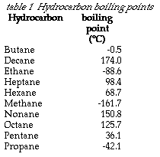

- If a mixture of these two metals is heated, circle which substance will melt first (based on their melting point (mp):
lithium lutetium
- If crushed and placed in foaming water which substance would sink fastest (based on their specific gravity):
lutetium magnesium
- If a mixture of the following two metals was heated until it was completely liquid and then allowed to cool, circle which substance would freeze (become solid) first ,based on their melting point (mp):
magnesium lutetium

