Separating substances as particles  E.H.S. ©λ#M!$+rγ  Mr. Genest |  | Name_________________  Date__________________  Tutors! Adults! Help this young chemist by visiting http:genest.weebly.com with any smart phone
- Classify each mixture as heterogeneous or homogeneous

  - _________________ snow
  - _________________ Gatorade
  - _________________ sand
  - _________________ ice cubes

- If you spun each box of stuff in a centrifuge, how many layers would it make?  - _______ Box A  - _______ Box B  - _______ Box C |  | 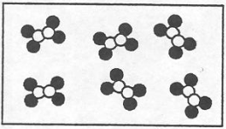 | 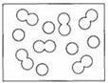 | 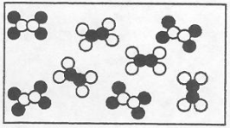
 |  | A | B | C

- If a 64.1g disc made of unknown metal is heated using 349 joules, its temperature rises 3.79°C. Calculate the specific heat of the disc.

- Uranium centrifuges separate valuable Uranium 235 from the heavier, less useful Uranium 238 The physical property that allows the separation to work: Uranium 235 is less dense than Uranium 238 and stays near the center of the centrifuge when spun. Draw a particle picture as follows: a homogeneous mixture of U235 and U238 in centrifuge A before it is spun and then the same mixture in B after it has been spun for an hour.
A | B

Key:

- Heptane and Hexane are colorless liquids at room temperature that mix very easily and completely. Imagine that you have placed a mix of these two liquids in the distillation flask shown here. As the first liquid starts to boil up, draw in the boxes below draw particle model pictures, for locations A , B, and C in this image.  A B C  Key: | 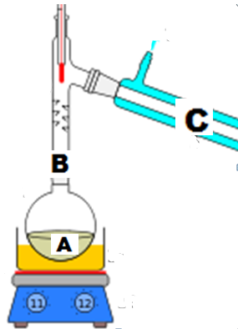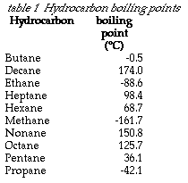

- Haagen Dazs makes a type of ice cream called Five. The ice cream’s ingredients are skim milk, sugar, cream, ginger, egg yolks. The first two ingredients mix well with each other. The last three ingredients mix well with each other. But the first two ingredients, microscopically don’t mix with the last three. This would make a □homogeneous mixture □ heterogeneous mixture. Draw a particle picture, with a key, of what this ice cream looks like microscopically.
- Chromatography
- In chromatography, ink can be separated into multiple substances. This proves ink is not a substance. The pictures at the right are from a student that started with a dot of ink and then allowed chromatography to separate the ink into dots, like we did in lab.  In the boxes below, draw particle pictures to describe this. Include particles that show the liquid solvent.  (a) before (b) after  Key: | before:  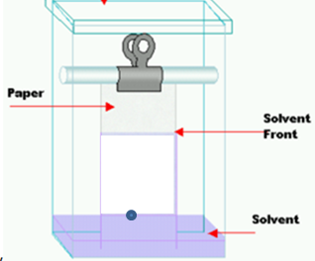  after:  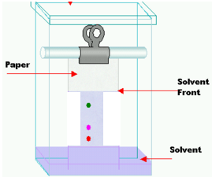

- If a disc made of unknown metal is heated using 349 joules, its temperature rises 7.75°C and it has a specific heat of 0.339 J/g°C. Calculate the mass of the disc.

