|  |  |  |
| --- | --- | --- |
| *compounds*  CλeMis+ry [eagenest@madison.k12.wi.us](mailto:eagenest@madison.k12.wi.us) |  | Name_____________________  Period____________________ |

1. Using your Venn diagram from your notes, make a chart of every possible type of thing.

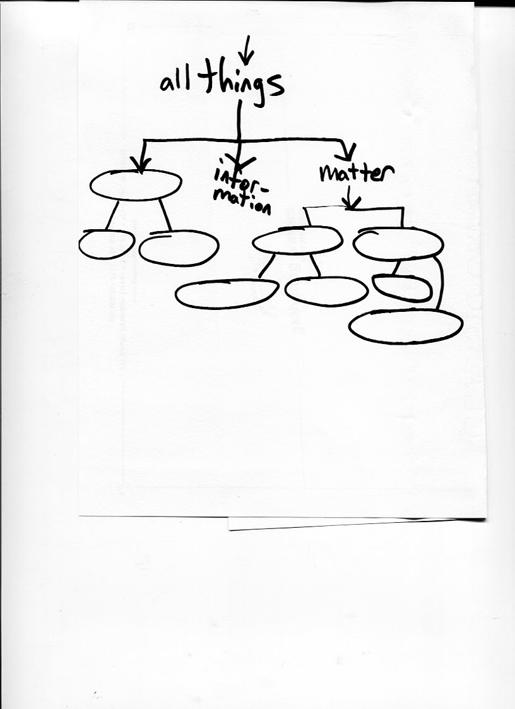

|  |  |
| --- | --- |
|  | 1. Categorize each square as either mixture, element, or compound:   A ____________________________________  B ____________________________________  C ____________________________________ |

|  |  |
| --- | --- |
| 1. Under each box write *solid, gas, or liquid*.     _________________ _________________ ____________________ | Circle your choice,  These boxes *all* contain a  Element?  Compound?  Mixture? |

***In each case, choose what thing was either added or removed from the UNDERLINED system. Choose the best answer. Some may not have an exact ‘correct’ answer, so give a reason.***

|  |
| --- |
| For your answer in each question write one of these types of things:  (E) energy (I) information (M) matter |

1. New paper is written on by a note-taking college student

E, I, or M? _________ added or removed? ___________ Why you think this: ______________

1. A tennis ball falls off of the school roof and lands on the grass

E, I, or M? _________ added or removed? ___________ Why you think this: ______________

1. As you walk home, your water bottle leaks and when you get home there is no water in it.

E, I, or M? _________ added or removed? ___________ Why you think this: ______________

1. A taut archery bow releases and sends an arrow flying.

E, I, or M? _________ added or removed? ___________ Why you think this: ______________

1. After 500 million years of rain and wind, the Appalachian mountains are one third of their original mass.

E, I, or M? _________ added or removed? ___________ Why you think this: ______________

1. You buy a new cell phone and immediately download a cat video

E, I, or M? _________ added or removed? ___________ Why you think this: ______________

1. A taut archery bow releases and sends an arrow flying. (this is different than the other bow question!)

E, I, or M? _________ added or removed? ___________ Why you think this: ______________

1. A player holding cards in a royal flush ( 10 through Ace, all the same suit, in order) throws down her hand and the cards are shuffled back into the deck

E, I, or M? _________ added or removed? ___________ Why you think this: ______________

1. Your dad memorizes a book that explains how to knit sweaters.

E, I, or M? _________ added or removed? ___________ Why you think this: ______________

1. A forest is chopped down and burned.

E, I, or M? _________ added or removed? ___________ Why you think this: ______________

1. You fill a bag with sand at the beach.

E, I, or M? _________ added or removed? ___________ Why you think this: ______________

1. A glitch in your computer erases your USB flash drive.

E, I, or M? _________ added or removed? ___________ Why you think this: ______________

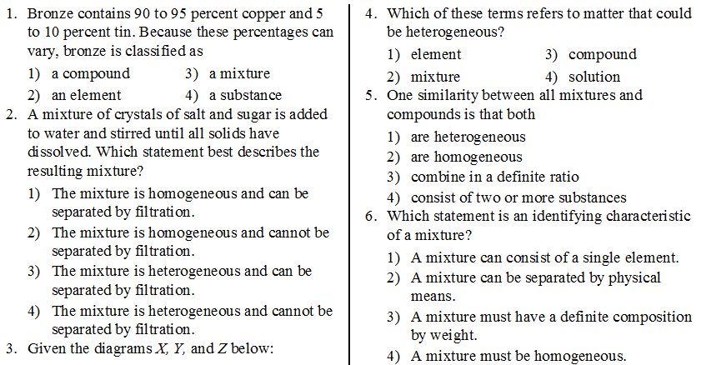

|  |  |
| --- | --- |
| 1. Under each box write *solid, gas, or liquid*.     _________________ _________________ ____________________ | Circle your choice,  These boxes *all* contain a  Element?  Compound?  Mixture? |

|  |  |
| --- | --- |
| 1. Under each box write *solid, gas, or liquid*.     _________________ _________________ ____________________ | Circle your choice,  These boxes *all* contain a  Element?  Compound?  Mixture? |

|  |
| --- |
| For each mixture separation below, choose which property each separation relies on.  For your answer in each question write one of theseproperties:  (BP) different boiling points (S) different solubilities (MP) different melting points  (D) different densities |

1. __________Ethanol can be separated from water by distillation
2. __________Uranium 235 can be separated from harmless Uranium 238 by spinning it in a centrifuge
3. __________Mountain Dew will be sweeter if you freeze it and remove the ice crystals that form .
4. __________ Muddy salt water can be made transparent by pouring it through a filter.

|  |  |
| --- | --- |
| There is a mixture of sugar, sand, and water at “A” | There is a mixture of sugar, sand, and water at “C” |

|  |  |
| --- | --- |
| 1. If you tried to separate a mixture of sugar, sand, and water in the above pictures, draw particle pictures to explain what would be in each place.   First draw a key to show | |
| Key: | |
| What would we see at A? | What would we see at B? |
|  |  |
| What would we see at C? | What would we see at E? |
|  |  |