Physical Changes vs Chemical Changes  East HS Chemistry  Mr.Genest | 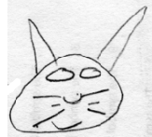 | Name__________________________  Period __________
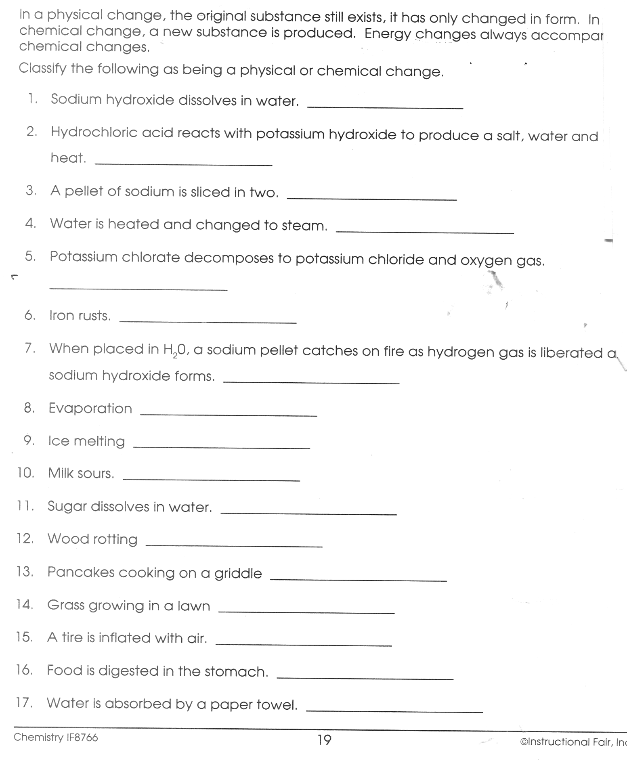
5. Consider the four containers below.
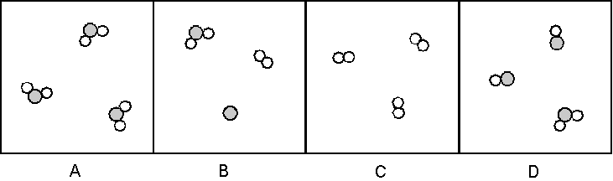
a. Which of these are mixtures? pure substances?

b. Which contain only compounds? only elements

6. Consider the four containers below.
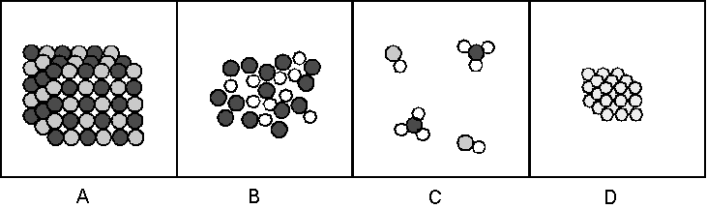
a. Which of these are mixtures? pure substances?

b. Which contain only compounds? only elements

7. Consider the four containers below.
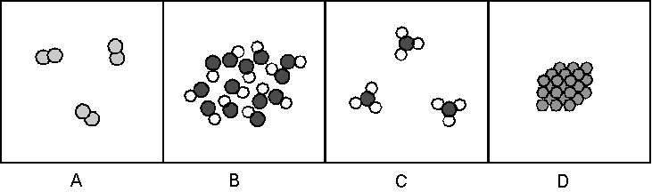
a. Which of these are mixtures? pure substances?

b. Which contain only compounds? only elements

8. Which of the containers in #7 contain a gas? a liquid a solid

