Math Practice for the January Final Exam #1  East.H.S. ©λ€M|5+rγ | 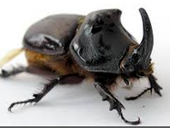 | Name_________________  Date__________________  visit http://genest.weebly.com

- If you have 7030. kg, how many Gg do you have?

- If you have 0.005011 kiloliters, how many microliters do you have?

- We describe three storage “accounts” to understand the changes we see in chemistry. State their names and describe how energy is stored in these three storage modes

- A tray of water (20 ˚C) is placed in the freezer and turns into ice cubes (- 8 ˚C)
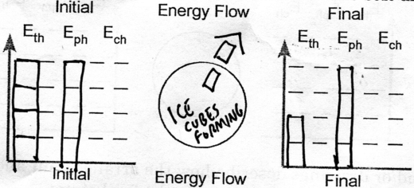
List one or more mistakes in the solution shown above

- These numbers will NOT be given to you on your final exam. You will only be given a periodic table. Instructions: Write down some of these and any numbers like these onto your ‘cheat sheet’ now
You will always be given these numbers on tests and quizzes.
0 degrees C = 273 kelvins do you know the definition of absolute zero?
760. torr = 760. mmHg = 1.00 atm = 101 kPa = 101,300 pascals = 14.7 p.s.i.
1.00 mole of things is 6.02x10²³ things. \
** you should either memorize your metric units or commit them to your sheet

- How many mm Hg are in 77.3 kPa?

- How many torr are in 1.19 atm?

This is a before and after problem. Your solution should be a ‘lonely number’* followed by one or more ratios.
- A quantity of gas exerts a pressure of *98.6 kPa at a at a temperature of 22.0 °C. If the volume remains unchanged, what pressure will it exert at -8.0°C?

- If a beachcomber finds a copper coin that contains 8 x 10²¹ atoms of copper, what is the volume of the coin? Assume that 255 atoms of copper have a mass of 2.69 x 10⁻²⁰ grams. Also assume that the density of copper is 8.98 grams per mL.

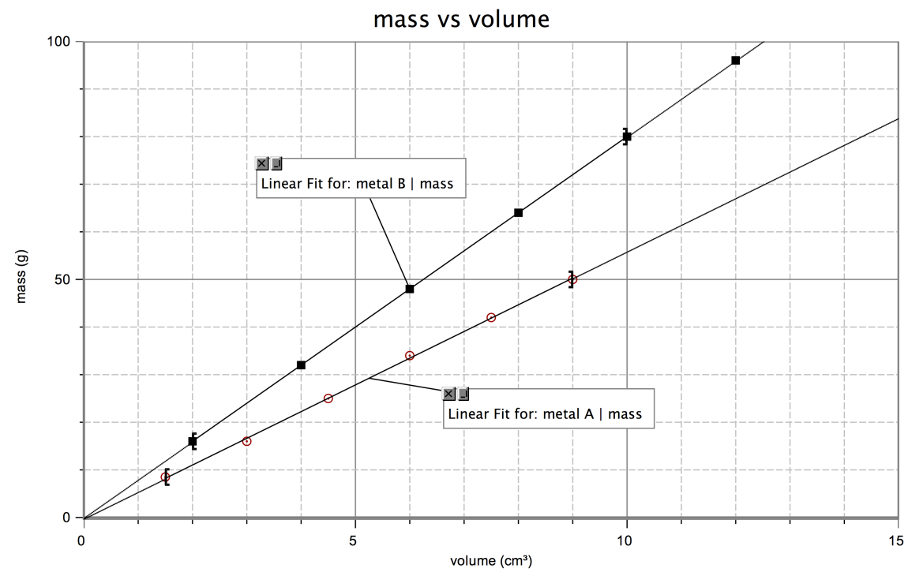
- Based on this graph, how does metal B differ from metal A?

- Based on this graph,What is the density of metal B? Show all your work and include appropriate units.

- Based on this graph,What is the mass of 9.0 cm³ of metal B?

- A student filled a graduated cylinder with water and read the meniscus at 25.8 mL. The student then dropped a solid material into the graduated cylinder and the water level rose to 35.9 mL. If the solid material had a density of 2.99 g/mL, determine the mass of the solid object.

Substance Density (g/mL)  Aluminum 2.70  Titanium 4.54  Zinc 7.13  Tin 7.31  Iron 7.87  Nickel 8.90  Copper 8.96  Silver 10.50  Lead 11.35  Mercury 13.55  Gold 19.30  you don’t need to put numbers like this on your cheat sheet | - You made some cubes out of each metal in the table that each measures 2.00 cm on every side.  a. What is the volume of each cube in cm³? in mL?  V = ______ cm³ V = ______ mL
. b. Find the mass of these metal cubes: (Show your work below)
lead cube ______________
nickel cube ______________
zinc cube ______________

- Round each to two significant figures
- 550.9 is ____________________
- 951236 is ____________________

- How many significant figures are in each measurement below?
- 75000 miles _____________
- 903.0 g _____________
- 800.9520 _____________
- 0.0005000050 nm ____________
- Convert the following into scientific notation:
- 745

- 0.00852

Convert the following to “normal” numbers (with no exponents anywhere)
- 7.2 x 10⁻²

Mark (H) or (T) for each item below indicate whether it applies to HEAT or TEMPERATURE
- _____ is measured with a cup of water called a Calorimeter
- _____ is just a measure of the average speed of the particle vibrations
- _____ one common unit for measuring this is joules

- A cube of aluminum with a density of 2.70 g/mL has a volume of 52.8 mL, what its mass? (Hint, find the numbers in a relationship, find the lonely number, find the unit for the answer. Set up words before numbers.)

- Is this a substance? (yes / no ) | 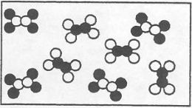

- Using the picture on the right, determine  the pressure of the gas if the atmospheric  pressure is 735 mm Hg.  - If the CH₄ gas became colder the height of liquid would  - still be 30.0 mm  - be greater than 30.0 mm  - be less than 30.0 mm  - If the atmospheric pressure became less (due to bad weather) the height of liquid would  - still be 30.0 mm  - be greater than 30.0 mm  be less than 30.0 mm  - How many torr is the ambient pressure in this story problem? | 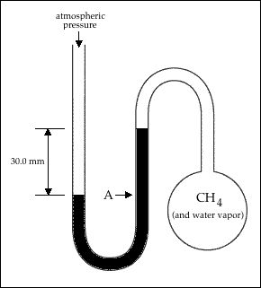

- Write your best estimate of the length of this object using
- The left ruler: ______________
- The right ruler: ______________
