Math Practice for the January Final Exam #2  East.H.S. ©λ€M|5+rγ |  | Name_________________  Date__________________  visit http://genest.weebly.com

The most useful single item to review is the stapled together sheet that looks like this (available at the class website):
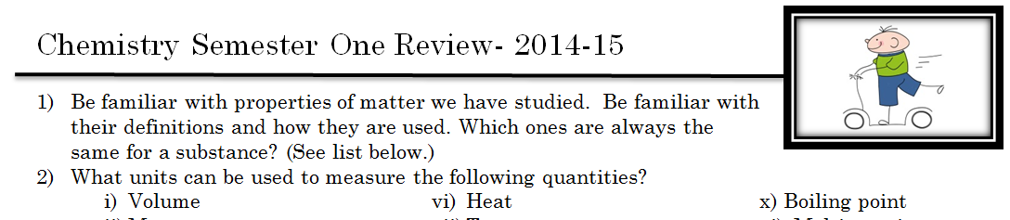

However, this sheet you are holding is good for practicing some of the math problems that will be on the test.

- How many silver atoms are contained in 0.650 grams of silver?

- How many moles are in a 12.0 g sample of FeO?

- What is the mass of 0.015 moles of Ca(OH)2?

- What is the percent by mass of Ca in calcium chloride, CaCl2?

- If you have 505 μL, how many L do you have?

- If you have 0.34 μm, how many picometers do you have?

- Given info: You buy a used car and in the trunk find an Tupperware tub with a substance. When analyzed it has6.93g of oxygen and 0.43 g of hydrogen. If the molar mass of the compound is 34.0 g/mole, what is the molecular formula? | Find the empirical formula
Find what the mass would be for a mole of this empirical formula. |  | Now randomly choose a few integers and multiply your empirical mass by them.  Write the molecular formula here _____________

- Is your cheat sheet up to date? You can bring an 8.5” x 11” sheet, handwritten, not photocopied, not computer-printed. Include formulas, a metric conversion table, 6.02x10²³…

- How many torr are in 99.3 kPa?

Substance Density (g/mL)  Aluminum 2.70  Titanium 4.54  Zinc 7.13  Tin 7.31  Iron 7.87  Nickel 8.90  Copper 8.96  Silver 10.50  Lead 11.35  Mercury 13.55  Gold 19.30  you don’t need to put numbers like this on your cheat sheet | - What would be the mass of a 44.8 mL piece of tin?

- If 13.6. grams of metal were dropped into 28.5 grams of water calculate the following
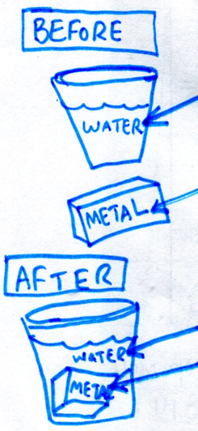 | 16°C water  92°C metal  35°C water  35°C metal | - Find ∆T for the water.  - How many joules of heat entered the water?  - Find ∆T for the metal

