Empirical  CλeMis+ry: http://genest.weebly.com  Stop in for help every day at lunch and Tues &Thurs after school! |  | Name_____________  Period_____________

Convert each of the following into an empirical formula:

- C₁₄H₁₄O₂ (naproxen: “Alleve”)
- C₆H₆ (Benzene)
- C₉H₈O₄ (aspirin)
- C₂H₂ (acetylene welding gas)

- Which of the compounds above have the exact same empirical formula? ____________

- What is the empirical formula for a compound that has 69.94 grams iron and 30.06 grams of oxygen?

- What is the empirical formula for a compound that is 40.0 grams of carbon, 6.7 grams of hydrogen, and 53.3grams of oxygen ?

5. A sample of iron oxide was found to contain 1.116 g of iron and 0.480 g of oxygen. Its molar mass is roughly 5 x as great as that of oxygen gas. Find the empirical formula and the molecular formula of this compound.

7. Find the percentage carbon of a compound that contains 1.94 g of carbon, 0.48 g of hydrogen, and 2.58 g of sulfur in a 5.00 g sample of the compound.

Key to understanding the cartoons on this sheet:
1 chlorine atom |  | 1 hydrogen atom | 1 oxygen atom |  | 1 nitrogen atom | 1 carbon atom
 | - Calculate the molecular mass of this molecule shown at the left.
- How many atoms, total, are in this box? _____
- How molecules are in this box? _____
- The What is the molecular formula of this compound? ____
- What is the empirical formula of this compound? ____

- How many atoms, total, are in this box? _____
- How molecules are in this box? _____
- What is the molecular formula of this compound? ____
- What is the empirical formula of this compound? ____

17 A compound composed of hydrogen and oxygen is found to contain 0.59 g of hydrogen and 9.40 g of oxygen. The molar mass of this compound is 34.0 g/mol. Find the empirical and molecular formulas.

PAGES 1 &2 MANDATORY. PAGES 3 &4 OPTIONAL. WON’T BE CHECKED. ANSWERS WILL BE GIVEN AND I WILL ANSWER QUESTIONS ABOUT THEM
18Find the percentage composition of a compound that contains 17.6 g of iron and
10.3 g of sulfur. The total mass of the compound is 27.9 g.

19 What is the % by mass of oxygen in Mg(NO3)2 ?

- Write the measurement for each letter. Always make the last digit zero when the hairline hits the mark dead center.
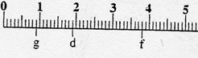 G ______ D________ F________

 | - Answer questions  for these lines. Line A  has been done below for you  as an example. |  | 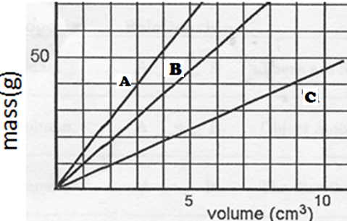
For Line A  - Calculate the slope  of Line A  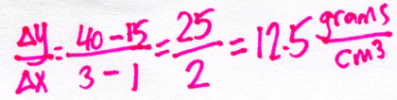  - Write a “For every…” sentence.  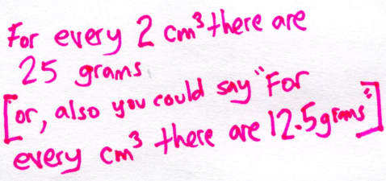 |  | - For Line B  - Calculate the slope of Line B  - Write a “For every…” sentence. |  | - For Line C  - Calculate the slope of Line B  - Write a “For every…” sentence.
- What is the answer, to the correct number of significant figures of each

  - 83 x 0.7 =
  - 83 + 0.7 =

- The Law of Conservation of Mass says that ___________________________________________

- before: a wet cotton ball on the ground, after: same cotton ball after six hours in the sun [Your drawing should explain why the total mass decreases.] |  | macroscopic view |  |  | microscopic view
 |  | before | after |  | before | after
Symbols that I used:

- Write the measurement for each letter. Estimate between marks when the hairline doesn’t hit dead center. If it does, make the last digit zero.
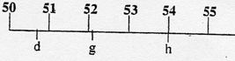 D ______ G________ H________
- Write the measurement for only g, h, & f in these blanks
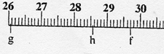 G ______ H________ F________

