Son of Molecular Mass  CλeMis+ry: http://genest.weebly.com  Stop in for help every day at lunch and Tues &Thurs after school! |  | Name_____________  Period_____________

- What is the molecular mass of C₄H₈?

- Of all the letters in this square, what percent are X’s? | O O H X X O O O X O X H O H

Useful information about dried garbanzos: | Each garbanzo weighs 0.6362 grams | A box contains 24 bags of beans
 | Each bag of garbanzos contains 1062 beans | Each bean is 73 protein by mass.

- How many beans will there be in 3 bags of garbanzos?

- What would be the mass of 2.1x10⁻¹⁵ moles of garbanzos?

- What will be the mass of 13 boxes?

- How many moles are in 650000000000000000000000000 garbanzo beans?

- A strong wind has blown a bunch of conversion factors away from Problem #4! Worse still they have lost their numbers! Fill in top and bottom numbers on each. You are only allowed to write in the following numbers: “1”, “6.02x10²³”, and anything from the periodic table.
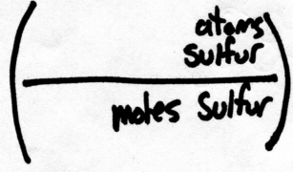
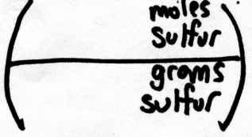
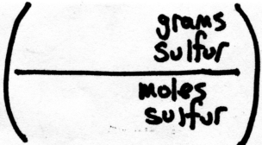
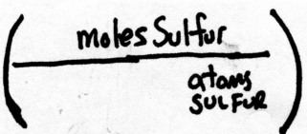

- Now, use the conversion factors you created above to solve the following problems below.

  - $\left(\begin{aligned}2.80x{10}^{24}atoms \\ of sulfur\end{aligned}\right) x\left(\frac{ }{}\right)= moles of sulfur$

  - $\left(\begin{aligned}0.360 moles \\ of sulfur\end{aligned}\right) x\left(\frac{ }{}\right) = atoms of sulfur$

  - $\left(\begin{aligned}2.80x{10}^{24}atoms \\ of sulfur\end{aligned}\right) x\left(\frac{ }{}\right)x\left(\frac{ }{}\right)= grams of sulfur$

- If you like the flavor cinnamon, you may be interested to know that its formula is C₉H₈O₂ …
If you are curious, the structure of a cinnamon molecule is this:  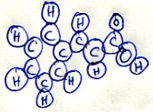 | According to the periodic table, what is the mass of a mole of this molecule? | A single piece of Trident® gum has about 7.902x10¹⁸ cinnamon molecules. What would be the mass of that many molecules of this substance?.
- What would be the mass of 4.77x10¹⁴ atoms of helium ?

- Of all the letters in this square, what percent are H’s? | O O H X X O O O X O X H O H

