Molecular Mass  CλeMis+ry  Final exams start January 20. See http://genest.weebly.com |  | Name_____________  Period_____________

Problems with a star (**) require you to use a periodic table to find the molecular weight to start the problem.)

- For the substance ammonia, NH₃…
How would you draw one molecule? | According to the periodic table, what is the mass of a mole of this molecule? **
 | Find the mass of 0.0550 moles of this molecule.

- For the substance fluorine gas …
How would you draw one molecule? | According to the periodic table, what is the mass of a mole of this molecule?**
 | Find the mass of 1.944x10²⁵ molecules of this substance.

- Find the molar mass** of the following:
a. Li₂S

b. FeCl₃

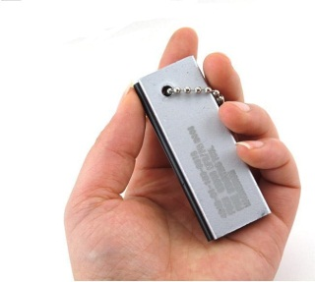
- This firestarter is made from magnesium. When you put it on a scale the scale reads 161 grams.
a. How many atoms are in the block?

b. If you had a block of the same substance that contains 9630000000000000000000000000. atoms of the same substance, what would be its mass in grams?

- How many hydrogen atoms are in a molecule of each of these substances?
a. Ca(OH)₂ _______ b. C₃H₈O ________ c. (NH₄)₃PO₄ _______ d. HC₂H₃O ________

- Complete the following table.
Element | Mass of one mole
Helium
Carbon
Gold

- **How many molecules are there in 4.00 grams of glucose, C6H12O6? (hint: first find the molecular weight of glucose. Then do a conversion using grams as your ‘starter number’.)

- **How many moles in 28 grams of CO2 ?

- How many moles of argon atoms are present in 11.2 L of argon gas at STP? (Remember that 22.4 liters of gas always contains a mole of that gas at 0°C, 1.000 atmosphere of pressure).

- **Find the mass, in grams, of 1.00 x 1023 molecules of N2. (Watch out, nitrogen is diatomic.)

- **Determine the volume in liters occupied by 14 g of nitrogen gas at STP. (Hint: see previous two problems. )

- Aspartame is an artificial sweetener that is 160 times sweeter than sucrose (table sugar) when dissolved in water. It is marketed by G.D. Searle as Nutra Sweet. The molecular formula of aspartame is C14H18N2O5 .
a) **Calculate the gram-formula-mass of aspartame.

b) How many moles of molecules are in 10 g of aspartame?

c) How many molecules are in 5 mg of aspartame? (recall there are 1000 milligrams in a gram)

d)(challenge!) How many atoms of nitrogen are in 1.2 grams of aspartame?

