Review for Thursday’s test  CλeMis+ry: http://genest.weebly.com  Stop in for help every day at lunch and Tues &Thurs after school! |  | Name_____________  Period_____________

- What is the empirical formula for a compound that is 40.0 grams of carbon, 6.7 grams of hydrogen, and 53.3grams of oxygen ?

- How many atoms, total, are in this box? _____
- How molecules are in this box? _____
- The What is the molecular formula of this compound? ____
- What is the empirical formula of this compound? ____

- 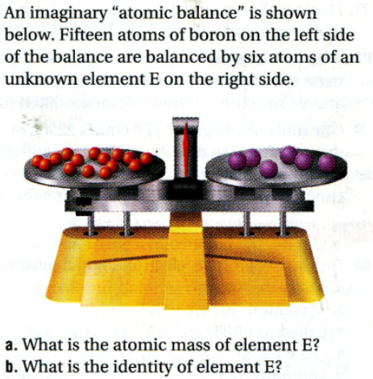
- Determine the molecular formula of the compound with an empirical formula of CH and a formula mass of 78.110 g/mole.

- The molar mass of a compound is 92.0 g/mole. Analysis of a small sample indicates it contains 0.606g N and 1.390 g of O. Find its molecular formula.

- How many atoms, total, are in this box? _____
- How molecules are in this box? _____
- What is the molecular formula of this compound? ____
- What is the empirical formula of this compound? ____
Convert each of the following into an empirical formula:

- Co₃H₉
- C₆H₁₂O₆ (fructose)
- C₂₄H₃₂O₄

- A sample of a chromium compound has a molar mass of 151.99 g/mol. Elemental analysis of the compound shows that it contains 68.43% chromium and 31.57% oxygen. What is the identity of the compound?

- For iodine…
How would you draw one molecule? | According to the periodic table, what is the mass of a mole of this molecule? | Find the mass of 9350000000000000 molecules of this stuff.
- What would be the mass of 3.08x10¹³ atoms of nickel?

