Names for Friday’s Quiz  East.H.S. ©λ€M|5+rγ | 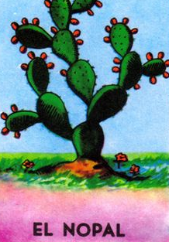 | Name_________________  Date__________________  visit http://genest.weebly.com

The list of which element names to know by Friday is at http:genest.weebly.com
It is the same list of elements that you memorized in September.

- In each case, either supply the missing symbol or the missing name. (memorize these by Friday)

I is iodine
_____ is tin
_____ is lead
Ag is __________
Au is __________
_____ is mercury
_____ is strontium
Ba is __________
_____ is uranium
Pu is __________
Si is silicon
P is __________
- Write the name of each compound. Use Rule 1 from class today: except in special cases, a name will be “ element + element + ide “
example Li₃P is “lithium phosphide
Ca₃N₂ is ________________________________
Na₃P is ________________________________
KBr is ________________________________
LiCl is ________________________________
Na₂S is ________________________________
NCl is ________________________________
- In each case, either supply the missing symbol or the missing name. (memorize these by Friday)

_____ is sulfur
Cl is __________
_____ is argon
_____ is potassium
Ca is __________
_____ is chromium
Mn is __________
Fe is iron
Ni is __________
_____ is copper

“
- Write the name of each compound. Use Rule 1 from class today: except in special cases, a name will be “ element + element + ide “
example Li₃P is “lithium phosphide
CaCl₂ is ________________________________
HCl is ________________________________
MgI₂ is ________________________________
NaBr is ________________________________
K₃P is ________________________________
K₂O is ________________________________

