Review #1  CλeMis+ry: http://genest.weebly.com  Stop in for help every day at lunch and Tues &Thurs after school! | 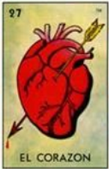 | Name_____________  Period_____________

Name each compound in the next six questions.

Situation 1: Metal with a predictable charge WITH a nonmetal
The name will be Element Name + Element Name + “-ide”

- Ca₃N₂
- Na₃P

-Situation 2: Metal from first two columns of the table WITH a polyatomic ion
The name will be Element Name + cheat sheet name

- MgCO₃
- Al(NO₃)₃

Situation 3: The metal on the left has an unpredictable charge.
The name will be Element Name + roman numeral that only tells the charge + element name + ide
- Fe₂O₃
- Cr₂(CO₃)₃

Situation 4: The substance is molecular, not ionic. [caveat: NEVER use this rule if a metal is present] .
The name will be di/tri/tetra/etc + Element Name + mono/di/tri/etc + element name + ide
- SO₃
- P₂S₅

.A | B | C | D
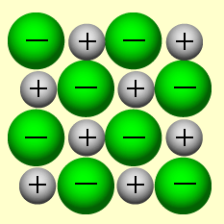

- Why are the + charges in ‘A’ not touching each other?
- In Box C, draw what ‘A’ would look like if dissolved in water. In Box D, draw what ‘B’ would look like if dissolved in water
- Which, if any of the boxes above show
- SOLID ___________________ GAS ___________________ AQUEOUS ___________________
- Which, if any, of the boxes would conduct electricity?
- How do you decide how many ions of each type combine to form an ionic compound?

- Why did JJ Thomson conclude that the mobile charged particle in the atom had a (–) charge? See your notes or la Campana Sheet

- Recall your representations of the atoms in the Sticky Tape activity. Below is a pair of tapes before they have been pulled apart. Explain why they would not exert a force (either attractive or repulsive) on one another.
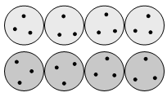
Use the following pictures of NEUTRAL atoms to answer the next four questions
Each big circle is one atom. Each black dot is one electron. This is how Thomson suggested atoms might be in his Plum Pudding model
neutral Hydrogen | neutral lithium | neutral nitrogen | neutral oxygen | neutral sodium
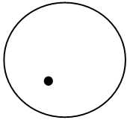 |  | 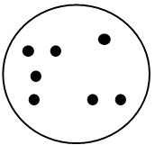 | 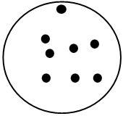 | 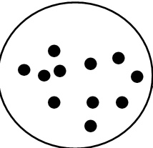
- Add black dots to show electrons into the two layers of atoms below so that the top layer is five neutral nitrogen atoms and the bottom layer is five anions that are each N³⁻ Would this attract , repel, or neither ? Explain.

- Add black dots to show electrons into the two layers of atoms below so that the top layer is five sodium cations that are each Na⁺ and the bottom layer is five anions that are each N³⁻ How many electrons are in each circle? Would this attract , repel, or neither ? Explain.

- Below is a group of the inner cores of a piece of metal foil. Sketch in where you would expect to find the mobile negative charges if a top (+) tape were brought to the left of the foil. Explain your diagram.

