Using all four naming rules  CλeMis+ry: http://genest.weebly.com  Stop in for help every day at lunch and Tues &Thurs after school! |  | Name_____________  Period_____________

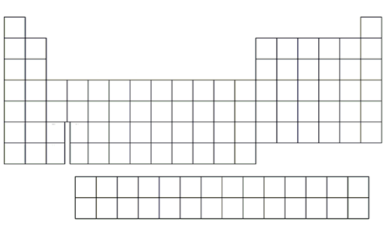 | - Use your periodic table to write the element symbols and charges for all of the following:  - The halogens  - Group 16  - The +1, +2, +3 elements near the middle of the table, that starts with silver

- Fill in just the formula. THEN write the name of the compound.
 | zinc | lead (II) | gallium | lead (IV)
chloride | ZnCl₂  zinc chloride
acetate
nitrate

- You should only use the Greek prefixes (mono, di, tri, etc) if the
compound is (ionic / molecular)
- You should never use the Greek prefixes (mono, di, tri, etc) if the compound contains a ( metal / nonmetal )
Name these using the mono, di, tri Greek prefixes

- C₂H₂ ________________________________________________
- N₂H₄ ________________________________________________
- PH₃ ________________________________________________

These are molecular compounds. Name them using the rules for molecular compounds (greek prefixes)

- N₂O₅  - P₂O₄  - C₂N₃ | - C₃N₂  - NI₃  - PF₂

read this! Use these asterisks to help you name the compounds in the squares below

*This has one metal and one nonmetal element. name it ELEMENT + ELEMENT + IDE
** This has three or more elements. You MUST use the polyatomic names from the back of your periodic table handout
*** This has a metal element with unpredictable charge, from the middle of the periodic table. You must assign a Roman Numeral. Don't be goofy: Roman Numerals DON'T tell how many atoms, they tell the "plus charge" of a single atom Example, in TiO2, the name is Titanium(IV) oxide. The "IV" means there is a plus four charge on the metal atom.

Mg(ClO₃)_{2 **} | NH₄NO_{3 **} | NaCl * | AgI *
CaSO_{4 **} | CaO * | PbO *** | Mg(MnO₄)_{2 **}
FeS *** | Fe₂S_{3 ***} | KMnO_{4 **} | Ca(OH)_{2 **}
Mo(ClO₄)_{2 ***} | CoCl_{2 ***} | CuBr *** | CoCl_{3 ***}

