ELECTRIC CHARGES  CλeMis+ry geneste@verona.k12.wi.us  The Thursday quiz never has something learned on Wednesday |  | Name_____________________  Date______________________  Keep this in your notes.

- The big rule in electric charge is: _______________________________________________________________.
- When you rub two different materials together, one sometimes gains __________ and the other loses _______.
This causes them to have ____________ charges because one is _______ and the other is ________
- When styrofoam is rubbed on wool, the styrofoam becomes negatively charged. This means the styrofoam (gained / lost ) electrons during the rubbing.
- When rubber balloons are rubbed on hair or fur, the balloon becomes negatively charged. This means the rubber (gained / lost ) electrons during the rubbing.

Gets a positive electric charge…  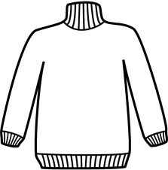  …so it must have (gained / lost ) electrons | Rubbed against | Gets a negative electric charge…  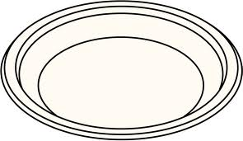  …so it must have (gained / lost ) electrons |  | Gets a negative electric charge…  …so it must have (gained / lost ) electrons | Rubbed against | Gets a positive electric charge…  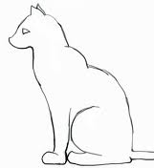  …so it must have (gained / lost ) electrons

 | proton | neutron | electron
Charge
Mass (in amu)

 | Protons | Neutrons | Electrons | Total Charge? |  |  | Protons | Neutrons | Electrons | Total Charge?
 | 4 | 5 | 3 | (+ / neutral / - ) |  | 7. | 1 | 1 | 1 | (+ / neutral / - )
 | 10 | 9 | 10 | (+ / neutral / - ) |  | 8. | 8 | 8 | 10 | (+ / neutral / - )

In everyday life there are three invisible forces that attract something:
 | A) If one thing has _______ and the other thing has _______ they will be attracted. |  |  | B) If one thing has _______ and the other thing has _______ they will be attracted. |  |  | C) If one thing has _______ and the other thing has _______ they will be attracted.

A few atoms from the top tape and the bottom tape are represented in the diagram below. Add electrons to each atom to show what happens to the electrons when we make a tape stack out of neutral pieces of tape and then pull them apart.
 |  | before |  | while touching |  | after
top  ( neutral) |  |  |  |  |  |  |  | top  ( charged +)
bottom  (neutral) |  |  |  |  |  |  |  | bottom  (charged -)

Describe the macroscopic changes in the tapes and then provide a microscopic explanation based on Thomson’s model of the atom and your drawings.

Behavior of Foil and Paper with Charged Tapes

We observed that neither foil (metal atoms) nor paper (non-metal atoms) would attract each other. But foil and paper are both attracted to both the charged tapes (top and bottom).
How can we use the pudding model of atoms to explain the differences we observed?

Several atoms from the paper and foil are drawn on the next page. The ones on the left have no charged object near them. The ones on the right are next to a top tape
(+ charge).
Add force vectors to the non-metal (paper) atoms and the top tape in the first row to show the attraction between the paper and the tape. Then do the same for the foil and the tape in the second row. Be sure the size of the vectors shows the relative strengths of the attractions.

Now draw the electrons in each atom “bowl” to show their arrangements when no charged object is near present and then when a charged object is brought near.
Non-metal (paper)
no charged object near
Non-metal (paper)
top tape near
Top Tape

Metal (Al foil)
no charged object near
Metal (Al foil)
top tape near
Top Tape

Explain why these arrangements of electrons would produce the observed attractions.

