What’s the charge on a Plum Pudding Anion?  E.H.S. ©λ#M!$+rγ  Mr. Genest | 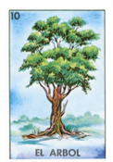 | Name_________________  Date__________________  Tutors! Adults! Help this young chemist by visiting http:genest.weebly.com with any smart phone

To review the empirical evidence, mark true or false for what we have shown.
Then, if false, write words that could replace the underlined words in order to make the statement true.
□True □False If something contains unequal amounts of positive and negative charge it will be neutral.
________________________________________________________
□True □False Top Tape attracts Top Tape. ___________________________________________________
□True □False In our lab, paper was an example of something that was neutral _____________________
□True □False In lab, Bottom Tape was an example of something that was neutral
□True □False Top Tape attracts Bottom Tape. ______________________________________________
□True □False In lab, paper was an example of something that was neutral
□True □False Thomson used a glass tube and 5000 volt electricity to cause electrons to shoot sideways and hit the end of the tube. ______________________________________________
□True □False In lab, top tape was an example of something that was neutral __________________

- The number of positive and negative things in the atom model shown here are equal.
What is our technical word for something that has exactly the same amount of negative and positive charge? ___________________

- If you add more raisins to the atom shown here, it will become
( negative / positive )

It’s super-important for us to know what the evidence is for the models of the atom this year.
Look at your notes from today, especially NOTE THREE. List an Observation that supports the following claims:
- Thomson claimed the stream he saw in his tube was made by particles, it was not ‘light’. _____________________________________________________________________________
- Thomson claimed the charge of each particle was negative _____________________________________________________________________________
- Thomson claimed that all matter contains these negative particles _____________________________________________________________________________

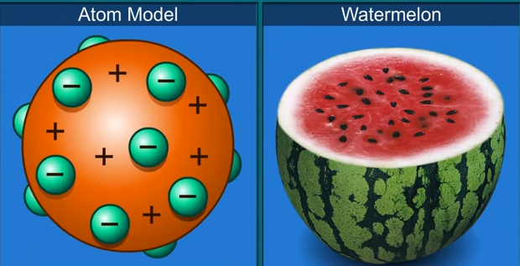 | - If Thomson had used a watermelon to explain his ideas about the atom,  What color would the positive charged part be?  ____________________  - What color would the negative charged part be?  ________________________

Here is a plum pudding drawing of one neutral ATOM of  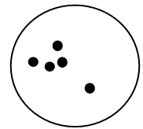  Element X | - If this is one atom of Element X, what is the charge of it? (-5 -2 -1 neutral +1 +2 +5 )  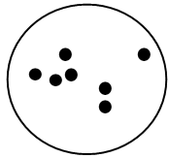 | - If this is one atom of Element X, what is the charge of it? (-5 -2 -1 neutral +1 +2 +5 )  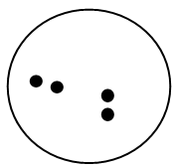 | - If this is one atom of Element X, what is the charge of it? (-5 -2 -1 neutral +1 +2 +5 )

- This is a drawing of Thomson’s experiment.
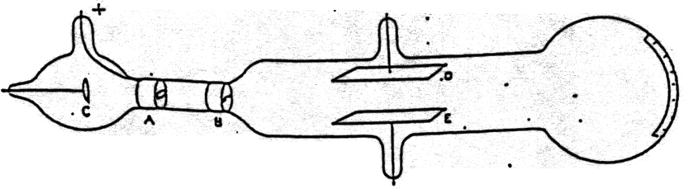
- Clearly label what part is the Cathode
- Clearly label what part glows when the electricity is turned on
- Clearly label what path the flying electrons follow when they travel in a straight line
- Clearly label what path the flying electrons follow when they curve
- If you want the flying electrons to curve, what should you bring near to the glass tube? ________________

- This is a pretty good drawing of what Thomson thought a Plum Pudding NEUTRAL hydrogen atom looked like. It shows a positive circle with one electron in it. Refer to it when answering the five questions below

one hydrogen atom | one hydrogen atom | 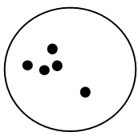  one hydrogen atom | one hydrogen atom | one hydrogen atom
The charge of the atom in this box is  - positive  - neutral  - negative | The charge of the thing in this box is  - positive  - neutral  - negative | This is (choose one)  - an anion  - neutral  - a cation | This is (choose one)  - an anion  - neutral  - a cation | This is (choose one)  - an anion  - neutral  - a cation

