Plum Pudding Atoms w/Charges  CλeMis+ry: http://genest.weebly.com  Stop in for help every day at lunch and Tues &Thurs after school! | 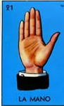 | Name_____________  Period_____________

Use the drawing below to answer #1 through #4 below.
Each circle here is an atom, each dot is an electron
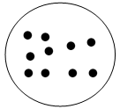 | ←atoms in sticky tape.  (they are neutral)
- Warm up questions:
  - How many atoms are shown in the box above? ______
  - What is the correct term for each circle? ( cation / neutral atom / anion )
  - What is the charge of a single ? ( -1 / zero / +1 )
  - If electrons are added to these atoms the charge of the tape will become more
( negative / positive )

- Using the neutral sticky tape atoms above as a reference point, draw appropriate numbers of electrons into each circle below.
an atom with two less electrons than a neutral tape atom |  |  | a cation with a charge of +1
an anion with a charge of -4 |  |  | a cation with a charge of +3

- Using the neutral sticky tape atoms above as a reference point, estimate the charge on each atom below.
The charge of this atom is  ( -2 / -1 / neutral / +1 / +2 ) | 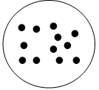 |  | The charge of this atom is  ( -2 / -1 / neutral / +1 / +2 ) | 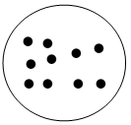
The charge of this atom is  ( -2 / -1 / neutral / +1 / +2 ) | 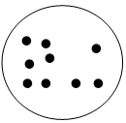 |  | The charge of this atom is ___________

- A neutral nitrogen atom looks like this according to JJ Thomson's Plum Pudding Model:  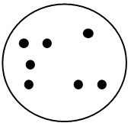  The charge is ( + / zero / - ) | Thomson would say this is a picture of  a) the plum?  b) the pudding?  The charge is ( + / zero / - ) | Thomson would say this is a picture of  a) the plum?  b) the pudding?  The charge is ( + / zero / - )

- Pulling the 'Top Tape' in our lab removed electrons from the Top Tape and added electrons to the Bottom Tape.

- This would cause the number of electrons in the Top Tape to (increase / decrease ).

- This would cause the number of electrons in the Bottom Tape to (increase / decrease ).

- Draw dots in each tape atom below to show your guess for how many electrons in the Top Tape and Bottom Tape (exact answers for each student will vary).
←atoms in Top Tape.
(cations)

←atoms in Bottom Tape.
(anions)

Use the following pictures of NEUTRAL atoms to answer the next four questions
neutral Hydrogen | neutral lithium | neutral nitrogen | neutral oxygen | neutral fluorine
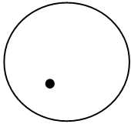 | 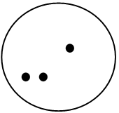 |  | 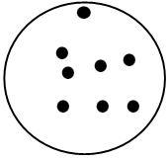 | 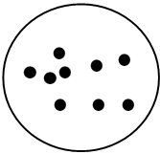

- Draw enough dots (electrons) on each atom to create the object described
a fluorine anion with a charge of -1 |  |  | a Li + cation
a nitrogen anion with a charge of -3 |  |  | a cation of hydrogen with a charge of +1

