find the carge on the metal ion  CλeMis+ry: http://genest.weebly.com  Stop in for help every day at lunch and Tues &Thurs after school! |  | Name_____________  Period_____________

1. Directions: cross out impossible compounds. Circle possible compounds. Use the rule: stable compounds must always be neutral; the total charge of a compound must be zero.

LiO
Li₂O
LiO₂
NaBr
NaBr₂
Na₂Br

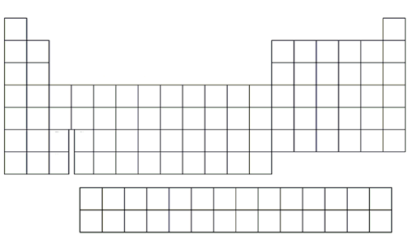 | - Color and label the part of the table where the elements often form a -1 ion.  - Color and label the part of the table where the elements often form a -2 ion.  - Color and label the part of the table where the elements always form a +1 ion.  - Color and label the part of the table where the elements always form a +2 ion.  - Write +1, +2, +3 on the ‘One-Two- Three zone near the middle of the table

- The big, big rule for forming compounds is
“the total charge of a compound is always ( +1 / zero / -1 ) “.
When a compound has this charge we say the compound is _______________ .

- For the compound lithium oxide, write the symbol for the lithium ion in the left box and the symbol for the oxide ion in the right box. |  | Cation Symbol: |  | Anion symbol: |  | Finally, write the formula of the neutral compound here:

- For the compound aluminum fluoride, write the symbol for the cation in the left box and the symbol for the oxide ion in the right box. |  | Cation: |  | Anion: |  | Finally, write the formula of the neutral compound here:

- What is the formula for sodium nitride?  - What is the formula for calcium phosphide? | - What is the formula for beryllium fluoride?  - What is the formula for magnesium fluoride?

- In each box,
  - draw a cartoon of the compound that will form. Use the same rule you used in Problem #1 on the front.
  - write the formula of what you formed (like K₂O)
  - write the name (like “potassium oxide”)
 | Br- | P³⁻ | O²⁻
Ca²⁺
Al³⁺
Fe²⁺
Fe³⁺

