Inventing appropriate conversion factors  CλeMis+ry: http://genest.weebly.com  Stop in for help every day at lunch and Tues, Weds., &Thurs after school!  After-hours question? Email me at home: eagenest@madison.k12.wi.us | 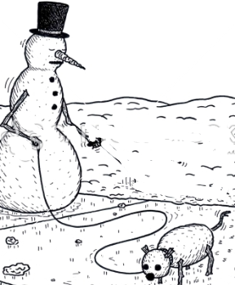 | Name_____________  Period________________

- Calculate the answer in each case, writing both number and correct UNIT.
  - $\left(\frac{4 moles Fe}{1}\right)x\left(\frac{ 3 moles H_{2}^{}O}{2 moles Fe}\right)x\left(\frac{ 18.02 grams H_{2}^{}O}{ 1 moles H_{2}^{}O}\right)=$
  - $\left(\frac{4 mL Fe}{1}\right)x\left(\frac{11 grams Fe}{2 mL Fe}\right)x\left(\frac{ 55.85 grams Fe}{ 1 mole Fe}\right)=$

 | 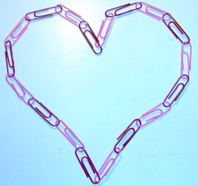 | 1 gross paperclips = 144 paperclips  1 paperclip = 3.00 cm long  1 paperclip = 0.977 grams
- Using only the information above, fill in these conversion factors
1 box of paperclips = ____ dollars
1 box of paperclips = ____ paperclips
1 paperclip heart = ____ paperclips

- Using only the Equalities above, fill in the missing conversion factors and calculate the answer.
- . $\left(\frac{9 paperclip hearts}{1}\right)x\left(\frac{ }{ }\right)x\left(\frac{ grams}{ clips}\right)=$ grams

- .$\left(\frac{33 clips}{1}\right)x\left(\frac{ }{ }\right)x\left(\frac{ dollars }{ boxes of clips}\right)=$ dollars

- . $\left(\frac{53 boxes of clips}{1}\right)x\left(\frac{ }{ }\right)x\left(\frac{ meters}{ cm}\right)=$ meters

- .$\left(\frac{13 dollars}{1}\right)x\left(\frac{ }{ }\right)x\left(\frac{ clips }{ boxes of clips}\right)=$ clips

- Imagine that 100. grams of aluminum and 100 grams of chlorine gas ( remember: wacky 7 formula for the chlorine molecule…) react according to the following stoichiometery
2Al_{(s)} + 3Cl_{2(g)} 2AlCl_{3(s)}
Which reagent will be the limiting reagent? How many grams of AlCl_{3(s)}will form?

Step 2) Both of your statements in Step 1 can’t be right. The one that will actually happen is the one that makes the least moles of product. Below this box write “The limiting reactant is____”

- Use the same three steps you used on the example from class. Imagine that 67.00 grams of aluminum and 60.50 grams grams of chlorine gas react according to the following stoichiometery
2Al_{(s)} + 3Cl_{2(g)} 2AlCl_{3(s)}
Which reagent will be the limiting reagent? How many grams of AlCl_{3(s)}will form?

