Five Reaction Types  CλeMis+ry: http://genest.weebly.com  Stop in for help every day at lunch and Tues &Thurs after school! | 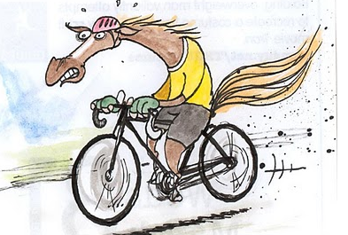by Edward Carter | Name_________  Period________

Predict the products for the following reactions then balance the equation,

 |  | Stop! Don’t touch this column until you get a stamp for the left hand column.
Write out the unbalanced version of  each reaction below |  | Now rewrite the same reaction as a balanced reaction.
CaCO₃ ? + ? (decomposition to form carbon dioxide and calcium oxide)

C₂H₄O₂ + O₂ ? + ? (combustion)

(single replacement) Na + Ag₂S ? + ?

(combination) silver metal and oxygen gas reacting to form just a single product

(double replacement)
NaOH + Ag₂SO₄ ? + ?

AgNO₃ + CuCl₂ ? + ?

(combustion) C₃H₆ + O₂ ? + ?

(combination) pure aluminum reacting with pure iodine to just a single product

(combustion) O₂ + C₅H₁₂O₂ ? + ?

(single replacement) Na + CaSO₄ ? + ?

(decomposition to form water and a pure element) H₂O₂ ? + ?
Get a stamp here:
- Another name for a combination reaction is a ______________ reaction.

- In this reaction, 3H₂ + 1N₂ 2NH₃
  - what are the big numbers (3, 1, 2) called? ( subscripts / coefficients )
  - what are the little numbers (2, 2, 3) called? ( subscripts / coefficients )

When you balance an equation, which are you allowed to change?
( the coefficients / the subscripts )

- When you are balancing a reaction, you are making sure it obeys
The Law of ______________

- Which type of reaction always has two reactants and one product?
□ single replacement reaction
□ double replacement reaction
□ combination reaction
□ decomposition reaction
- Which type of reaction always has one reactant and two products?

□ single replacement reaction
□ double replacement reaction
□ combination reaction
□ decomposition reaction
- Balance and classify each of the reactions below as one of the following reaction types

COMBUSTION,
DECOMPOSITION,
COMBINATION,
SINGLE REPLACEMENT,
DOUBLE REPLACEMENT

  - ___________ any reaction that has oxygen as a reactant and water and carbon dioxide as products
  - ___________ CH₄ + O₂ CO₂ + H₂O
  - ___________ Zn + Pb(NO₃)₂ Zn(NO₃)₂ + Pb
  - ___________ Mg + N₂ Mg₃N₂
  - ___________ H₂O₂ H₂O + O₂

