Review! (the test is Monday.)  CλeMis+ry: http://genest.weebly.com  Stop in for help every day at lunch and Tues, Weds., &Thurs after school!  After-hours question? Email me at home: eagenest@madison.k12.wi.us | R | Name_____________  Period_____________

For full credit: 1) you must work where your partner is working
2) Be in your regular desk 6 minutes before the bell for credit check.

- Write the standard pressure in ________ kPa ________ mmHg

Using the chart at right, answer each:
- If diethyl ether in this room had a vapor pressure of 600 mmHg would it be boiling?

- How high must the vapor pressure of a substance be at East High School for that substance to boil?

- Will the boiling point of a substance be higher on top of a mountain or in Madison?

- Fill in the empty boxes using the vapor pressure from the graph above.
substance | vapor pressure | the ambient pressure | Is the substance boiling? | temperature
ethyl alcohol |  | 500 mmHg | yes
diethyl ether | 400mmHg | 400 mmHg | yes
 | 600 mmHg | 760 mmHg | no | 74 °C
water | 200 mmHg |  | yes | 64 °C
- Draw your own heating curve for aluminum, knowing that it melts at 660 °C and vaporizes at 2467 Label the x-axis time and label the y-axis temperature.

- As temperature rises what happens to vapor pressure?

- The temperature at which all motion stops is ________ K or __________°C

- If the absolute temperature is increased four times higher what happens to the kinetic energy?

- Explain one way each of the following could happen.
  - Water boils at a temperature above 100 °C.

  - Water boils at a temperature below 100 °C.

- Show the work need to convert 50 mm Hg to kPa.

- The graph below is a phase diagram for substance. Label the following parts on the graph: sublimation line, normal boiling point, vapor/gas, liquid, solid, triple point, and critical point. | 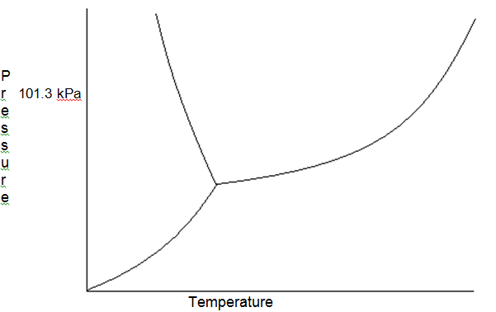

- Diamond and graphite are both made out of carbon. Explain how it is possible that one substance is one of the hardest things on Earth while the other breaks on us constantly.

