Five reactions & Review Naming  CλeMis+ry: http://genest.weebly.com  Stop in for help every day at lunch and Tues &Thurs after school! | 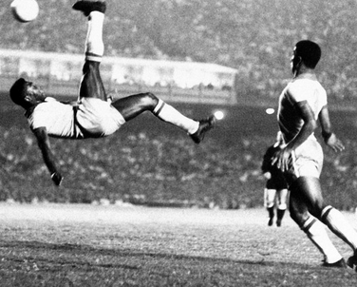  Pele vs. Belgium 1968 | Name_________  Period________

Predict the products for the following reactions then balance the equation,

 |  | Write the complete reaction as a balanced reaction.
(combustion of C₄H₁₀) |  | ______ + _______ ______ + _______
(combination)  pure calcium reacting with pure fluorine to just a single product |  | ______ + _______ ______
(combination)  calcium chunks and bromine liquid react to form a single solid substance (write the phases before you balance it) |  | ______ + _______ ______
(single replacement)  Na + CaSO₄ ? + ? |  | ______ + _______ ______ + _______
(Double Replacement)  AlBr₃ + K₂SO₄ ?? + ?? |  | ______ + _______ ______ + _______
(Single Replacement)  CuCl₂ + Al ?? + ?? |  | ______ + _______ ______ + _______
Did you remember to balance the six reactions above?

Chemical reactions either absorb or give off energy. This can be shown by writing energy as a reactant or product. Which of the two ways below would best describe this change of energy for a combustion reaction? (this is new for us – just make your best guess and we’ll give the answer tomorrow)

- CH₄ + 2O₂ + energy 2H₂O + CO₂
- CH₄ + 2O₂ 2H₂O + CO₂ + energy

When ammonium nitrate dissolves, the solution feels cold to touch.
Which of the two ways below would best describe this change of energy?
- NH₄NO_{3(S)} ₎ + energy NH_{4(aq)} + NO_{3(AQ}
- NH₄NO_{3(S)} NH_{4(aq)} + NO_{3(AQ)} + energy

You’re not finished yet. Make sure you also (1) get the lab ready to hand in Friday and (2) re-do old worksheets to get ready for the Friday Quiz

