Energy in Reactions  CλeMis+ry: http://genest.weebly.com  Stop in for help every day at lunch and Tues &Thurs after school! | 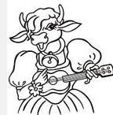 | Name_________  Period________

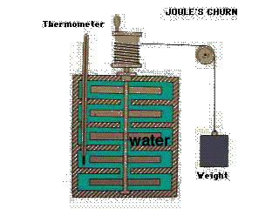
- If the candle is the system draw two bars in your bar graph and circle the correct choices:  Heat is ( entering / leaving ) the system. | - If the system is THE AIR above the candle  Heat is ( entering / leaving ) .  Energy of the system is (increasing / decreasing ). | - If the water in Joule’s churn is the system  The change to the system is (exothermic / endothermic ). | - If the system is THE AIR around the snowman  The change to the system is (exothermic / endothermic ).

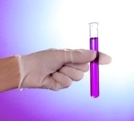 | If you mix some Barium Chloride and distilled water in a test tube and hold It in your hand, it feels cold!
 | - If the water and chemicals are defined as the system, the change in energy was  ΔE = (positive / negative )  The change was  ( exothermic / endothermic) | - If YOUR HAND is defined as the system, the change in energy was  ΔE = (positive / negative )  The change was  ( exothermic / endothermic)
- In exothermic reactions, is the energy of the products less or greater than that of the reactants?

- In an endothermic reaction, is the energy of the products less than or greater than that of the reactants?

- Convert each of the following energy units:
  - 8.1 kcal to cal

  - 2.50 kcal to J

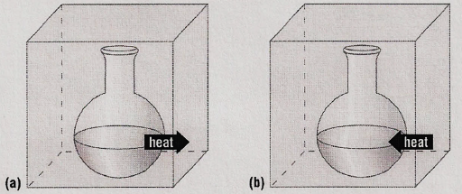
Some substances reacted in two flaskes. For each stzatement below, choose either Reaction A or Reaction B
- ________ For the substances in the reaction E_{ch} is decreasing
- ________ The reaction could be written A + energy B
- ________ The reaction could be written A B ∆H = -500kJ
- ________ The ∆H = + 300 kJ
- ________ The reaction is exothermic
- ________ The reaction would feel cold if you held the flask in your hand.
Energy in Chemical Reactions

- Classify the following as exothermic or endothermic:
- 550 kJ is released
- The energy level of the products is higher than that of the reactants.
- The metabolism of glucose in the body provides energy.
- The energy level of the products is lower than that of the reactants.
- 125 kJ is absorbed.
- Classify the following as exothermic or endothermic reaction and give ΔH for each:
- Gas burning in a Bunsen burner: CH₄ + 2O₂ → CO₂ + 2H₂O + 890 kJ
- Dehydrating limestone: Ca(OH)₂ + 65.3 kJ → CaO + H₂O
- Formation of aluminum oxide and iron from aluminum and iron(III)oxide:
- 2Al + Fe₂O₃ → Al₂O₃ + 2Fe + 850 kJ
- Combustion of propane: C₃H₈ + 5O₂ → 3CO₂ + 4H₂O + 2200 kJ
- Formation of table salt: 2Na + Cl₂ → 2NaCl + 2H₂O + 819 kJ
- Decomposition of phosphorous pentachloride: PCl₅ + 67 kJ → PCl₃ + Cl₂

