The energy in chemicals  CλeMis+ry: http://genest.weebly.com  Stop in for help every day at lunch and Tues &Thurs after school! |  | Name_________  Period________

- A combustion reaction can be described as follows.  CH₄ + 2O₂ 2H₂O + CO₂ + energy  Assuming that the system is WAX, draw an LOL energy chart that shows: wax as the system, both heat and light leaving the system, none of the ‘E’ changing except E_{ch}.  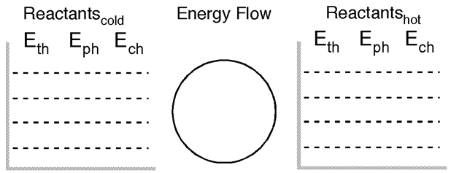 | - Dissolving ammonium nitrate in a first aid “cold pack” can be described as follows.  NH₄NO_{3(s)} ₎ + energy NH_{4(aq)} + NO_{3(aq)}  Assuming that the system is NH₄NO₃,, draw an LOL energy chart that shows: a label on the system circle, only heat entering the system, none of the ‘E’ changing except E_{ph}.

In each graph, draw only the bar graph for E_{ch} before and after. In each case the system is underlined.
- : for a system where gunpowder burns and gives off energy  Heat is ( entering / leaving ) the system. | - If the system is A ROCK that is hard to dissolve and needs energy added to dissolve it  Energy is ( entering / leaving ) .  Energy of the system is (increasing / decreasing ). | - If the ATP in your cells gains energy from you digesting a Snickers Bar  The change to the system is (exothermic / endothermic ). | - If the ATP in your cells gains energy from you digesting a Snickers Bar  The change to the system is (exothermic / endothermic ).

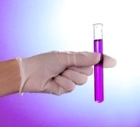 | If you mix some Barium Chloride and distilled water in a test tube and hold It in your hand, it feels cold!
 | - If the water and chemicals are defined as the system, the change in energy was  ΔE = (positive / negative )  The change was  ( exothermic / endothermic) | - If YOUR HAND is defined as the system, the change in energy was  ΔE = (positive / negative )  The change was  ( exothermic / endothermic)

- In exothermic reactions, is the energy of the products less or greater than that of the reactants?

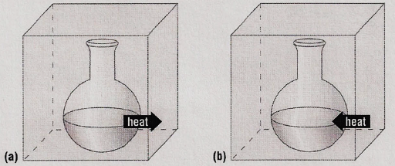
Some substances reacted in two flaskes. For each stzatement below, choose either Reaction A or Reaction B
- ________ For the substances in the reaction E_{ch} is decreasing
- ________ The reaction could be written A + energy B
- ________ The reaction could be written A B ∆H = -500kJ
- ________ The ∆H = + 300 kJ
- ________ The reaction is exothermic
- ________ The reaction would feel cold if you held the flask in your hand.
Energy in Chemical Reactions

- Classify the following as exothermic or endothermic:
- 550 kJ is released
- The energy level of the products is higher than that of the reactants.
- The metabolism of glucose in the body provides energy.
- The energy level of the products is lower than that of the reactants.
- 125 kJ is absorbed.
- Classify the following as exothermic or endothermic reaction and give ΔH for each:
- Gas burning in a Bunsen burner: CH₄ + 2O₂ → CO₂ + 2H₂O + 890 kJ
- Dehydrating limestone: Ca(OH)₂ + 65.3 kJ → CaO + H₂O
- Formation of table salt: 2Na + Cl₂ → 2NaCl + 2H₂O + 819 kJ
- Decomposition of phosphorous pentachloride: PCl₅ + 67 kJ → PCl₃ + Cl₂

