The energy in chemicals II  CλeMis+ry: http://genest.weebly.com  Stop in for help every day at lunch and Tues &Thurs after school! | 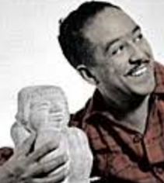 Langston Hughes, Harlem Poet | Name_________  Period________

For each of the reactions below, write the balanced chemical equation, including the energy term on the correct side of the equation. Then represent the energy storage and transfer using the bar graphs.

1. When you heated sodium hydrogen carbonate, you decomposed it into sodium carbonate, water vapor, and gaseous carbon dioxide.
balanced chemical equation, including the energy term on the correct side of the equation
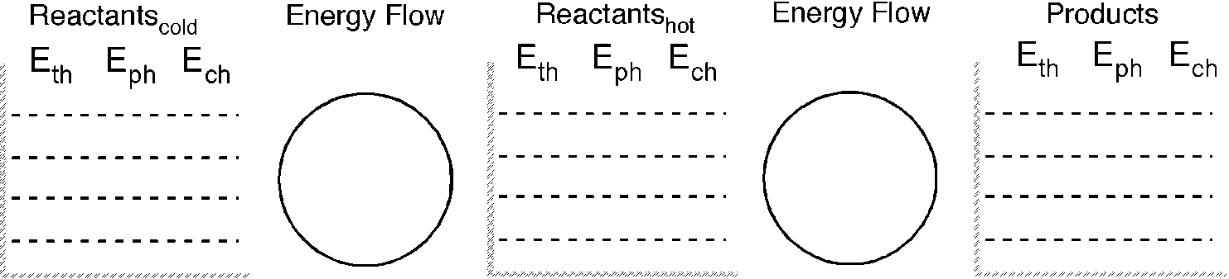

2. When solid zinc was added to hydrochloric acid, the products were hydrogen gas and an aqueous solution of zinc chloride. You could feel the test tube get hotter.

balanced chemical equation, including the energy term on the correct side of the equation
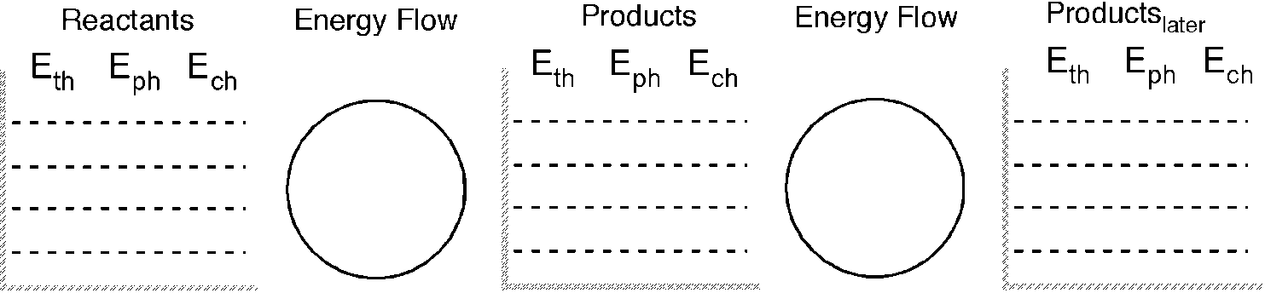
3. Isopropyl alcohol (C₃H₇OH) burns in air to produce carbon dioxide and water vapor.

balanced chemical equation, including the energy term on the correct side of the equation

4. In chemical cold packs, solid ammonium chloride dissolves in water forming aqueous ammonium and chloride ions. As a result of this solvation reaction, the pack feels cold on your injured ankle.

balanced chemical equation, including the energy term on the correct side of the equation

- In chemical hot packs, solid sodium acetate crystallizes from a supersaturated solution of sodium acetate. The pack feels warm to the touch for 30 minutes or longer.

balanced chemical equation, including the energy term on the correct side of the equation

