Review #1  CλeMis+ry: http://genest.weebly.com  Stop in for help every day at lunch and Tues &Thurs after school! | Beyonce | Name_________  Period________

- When potassium hydroxide pellets dissolve in water they form hydroxide ion and potassium ion, both aqueous. The reaction makes the tube feel very hot.
The balanced reaction is ______ _____ + _____
Touching the reaction makes your hand ( cold / warm)
Based on energy going in or coming out of the chemicals, either the left or the right side of the reaction above, write “energy”.
The reaction is (endothermic / exothermic )
When writing the delta H, we would write (choose one) ( ∆H = +344 joules ) ( ∆H = -344 joules )
Fill in the diagram below to describe the energy change.
In the first step, change only Ech and Eth. Do not let any energy enter or leave the system.
In the second step, change only Eth. And draw arrows to describe energy entering or leaving the system

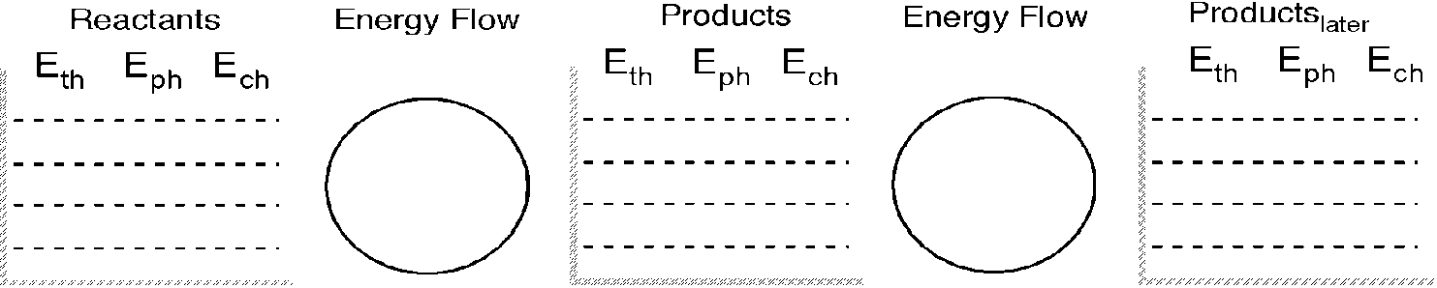

- When butane (C4H8) undergoes a combustion reaction, the reaction makes a blue flame.
The reaction is _____ +______ _____ + _____
Touching the reaction makes your hand ( cold / warm)
Based on energy going in or coming out of the chemicals, either the left or the right side of the reaction above, write “energy”.
The reaction is (endothermic / exothermic )
When writing the delta H, we would write (choose one) ( ∆H = +344 joules ) ( ∆H = -344 joules )
Fill in the diagram below to describe the energy change.
In the first step, change only Ech and Eth. Do not let any energy enter or leave the system.
In the second step, change only Eth. And draw arrows to describe energy entering or leaving the system

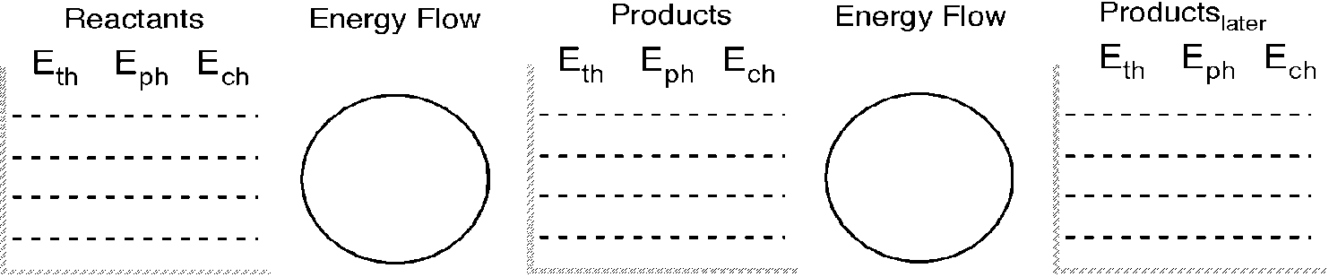

Write the unbalanced equations for the following chemical reactions.
You’ll need your periodic table and the back side of your periodic table.
Write a balanced reaction in each case below.
Write formulas (like H₂O) and phases (like s, l, g, aq):

- When dissolved silver nitrate (look up in your periodic table back) reacts with dissolved potassium chloride in water, silver chloride precipitate and aqueous potassium nitrate are made.

- When aluminum chloride and potassium carbonate are dissolved in water they react to form aqueous potassium chloride and aluminum caronate powder.

- The combustion reaction of the sweet-smelling substance in gasoline called benzene (C₆H₆).

