Name_________ | Unit 7 – The Details of Solids, Liquids, Gases and Their Changes

KUDos are a way of organizing our learning goals. By the end of this unit, you should know, understand, do:

KNOW: Things you need to ‘know’ are facts that you need to memorize and recall. They're the basic, lowest level foundation for beginning to understand this unit.

Vocabulary Word | Know it well | Have heard of it | Never heard it before | In my Words- Definition
allotrope
atmospheric pressure
barometer
boiling point
energy
heating curve (sometimes called a cooling curve)
kinetic energy
kinetic molecular theory
melting point
pascal (a unit, abbreviated Pa)
phase diagram
a unit abbreviated atm
triple point
vacuum
vapor
vapor pressure

UNDERSTAND: Chemistry is the study of matter and how it changes. There are a lot of details to understand about the changes. These are more complicated than just knowing the definitions of the words. Often a drawing is crucial to understanding.
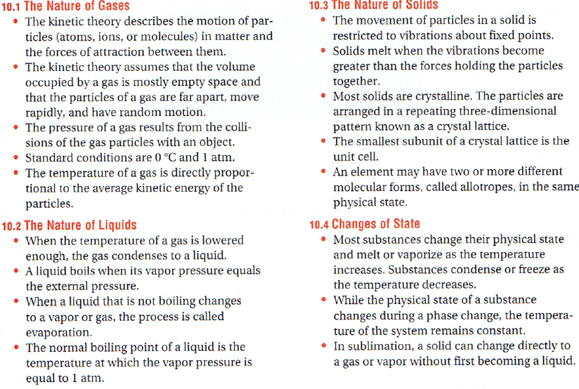

DO: The things you need to ‘do’ are skills and processes that you need to independently do. These are like the different actions you do to actually make a meal. You will be tracking your progress in the table below and you can check them off when you see you are ready for the test.

Goal | Progress on Goal |  |  | What do I still need to study?
- If given any three of the following find the fourth : { temperature, vapor pressure, boiling-or-not, name of the substance} with the assistance of a graph like on pp. 279 or 289
- If given a graph like on p. 272 describe the relative amounts of particlses that have certain amounts of energy
- Understand why the mm Hg and pressures are different in two drawings similar tp p. 277
- Make predictions about the changes that would occur if changes, including to the substance or temperature, were made to any of the drawings in sections 10.1 or 10.2 of the textbook
- If given a phase diagram (p. 284) predict the numerous combinations of pressures and temperatures that would be considered 'boiling points' and 'melting points'
(your textbook does a good job of explaining this unit on pp. 266 - 287)

