Using symbols to show chemical change.  CλeMis+ry: http://genest.weebly.com  Stop in for help every day at lunch and Tues &Thurs after school! | 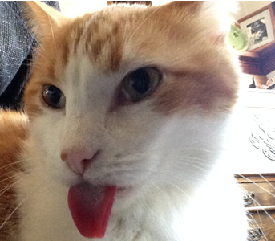 | Name_____________  Period_____________

After the formula of each reactant and product you give the state of the substance in brackets using the shortform indicated here:
- solid (s)
- liquid (l)
- gas (g)
- aqueous (aq) This means aqueous which means that the substance was dissolved in water or that it is in solution form.
- A precipitate is an insoluble solid formed during a chemical reaction with solutions. So (s) is used.

- When heated, solid carbon reacts with oxygen gas (wacky seven!) to form carbon monoxide (C₁O₁ or simply CO) gas.

- Aqueous ammonium chloride reacts with aqueous sodium hydroxide to form ammonia gas (NH₃), liquid water, and aqueous sodium chloride.

- Aqueous sodium phosphate and liquid water are formed when aqueous sodium hydroxide reacts with phosphoric acid(H₃PO₄).

- Solid carbon (see #1) reacts with oxygen gas to form carbon dioxide gas.

- Solid sodium reacts with liquid bromine to form solid sodium bromide.

- When heated, solid potassium chlorate yields solid potassium chloride and oxygen gas (see #1).

