|  |  |  |
| --- | --- | --- |
| Gases and Kinetic Energy  CλeMis+ry: http://genest.weebly.com  Stop in for help every day at lunch and Tues, Weds., &Thurs after school!  After-hours question? Email me at home: [eagenest@madison.k12.wi.us](mailto:eagenest@madison.k12.wi.us) | http://1-media-cdn.foolz.us/ffuuka/board/a/image/1337/08/1337080842239.png | Name_____________  Period________________ |

|  |  |
| --- | --- |
|  | Check one or more:  _______ molecules that are elements are present  _______ molecules that are compounds are present  _______ this is a mixture  _______ this is a pure substance |

|  |  |
| --- | --- |
| 1. . | Check one or more:  _______ molecules that are elements are present  _______ molecules that are compounds are present  _______ this is a mixture  _______ this is a pure substance |

1. List the four units used for measuring pressure.
2. Convert 1656000 pascals to atm
3. If the following gases are all at STP, put <, = , or > to **compare the number of particles**:
   1. 1 mole of O2 _______ 1 mole of N2
   2. 22.4 liters of O2 _______ 22.4 liters of N2
   3. 44.8 liters of neon gas ______ 22.4 liters of neon gas
4. Convert 190 mmHg to kPa
5. What is the relationship between the absolute temperature of a substance and its kinetic energy.

KE necessary to escape

KE

% particles with given KE

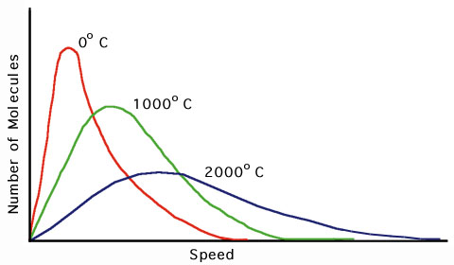

**2000°C**

1. In the above diagram, draw a vertical line on each curve in the location where you estimate half of the area under the curve is to the left of your line and half is to the right. Write “average temperature” above these lines.
2. Color in the half of the curves that are to the left of the line you drew.
3. If only the fastest moving 50% of the particles left each curve, where would be the new midpoint of the particles that remained? Draw a vertical line in the midpoint of the area you shaded in on the left half. Write *new average temperature* over those lines.
4. In all evaporation, including perspiring and sweating, how is the temperature changed for the liquid that remains behind as the other liquids evaporate?
5. 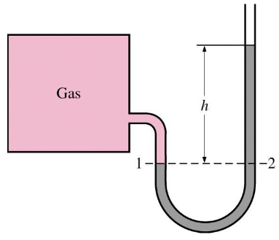If this manometer and box contained 2x1022 atoms of helium and then you added another 2x1022 atoms of helium, the height of liquid shown by “h” would
   1. decrease
   2. stay the same
   3. increase
6. If the picture of this manometer and box was taken in a room in Madison (elevation 800 feet) but the box was later moved to Boulder, Colorado (useful elevation data is at the top of this page…) the height of liquid shown by “h” would
7. decrease
8. stay the same
9. increase