The Vapor Pressure of a Liquid  CλeMis+ry: http://genest.weebly.com  Stop in for help every day at lunch and Tues, Weds., &Thurs after school!  After-hours question? Email me at home: eagenest@madison.k12.wi.us | 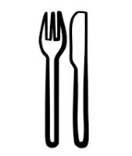 | Name_____________  Period_____________

- Consider these liquids at room temperature:
SUBSTANCE | A |  | B |  | C
 | 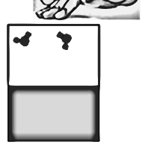 |  | 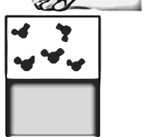 |  | 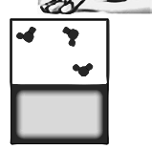
What temperature?
HOW MUCH VAPOR PRESSURE

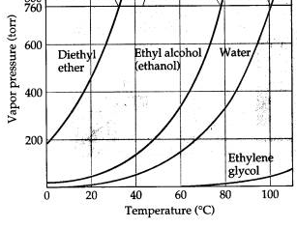
- Label the three boxes below as “60 degrees C”
Draw a manometer in each box. Instead of water, label the liquid in each as either degree ethanol, water, or diethyl ether. Draw how many particles would be vapor. Move the Hg to show your prediction for how far it would be pushed to the right.

- Graph this data. Label the X-Axis temperature. Number it from 0 to 100. Label the Y-Axis vapor pressure. Number it from 0 to 900. Draw dots with circles for data points. Connect your data points with a line.
temperature [°C] | vapor pressure [torr]
30 | 20
50 | 110
60 | 200
70 | 300
80 | 400
90 | 600
100 | 800

The graph you made above shows that as temperature decreases, the vapor pressure of a substance will become ( lower / higher ). This makes sense because as temperature decreases, the kinetic energy of the liquid ( decreases / increases ) and therefore the amount of liquid changing to vapor will be ( less / more )

- Label the three boxes below as water.
Draw a manometer in each box. Each box as either 60, 80, or 100 degrees water. Draw how many particles would be vapor. Move the Hg to show your prediction for how far it would be pushed to the right.

