Turning Unbalanced Reactions into Balanced Reactions  CλeMis+ry: http://genest.weebly.com  Stop in for help every day at lunch and Tues &Thurs after school! | Jean Michel Basquiat 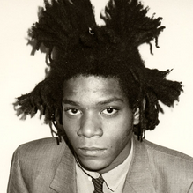 | Name_____________  Period_____________
Add more cartoon atoms until they obey the Law of Conservation of Mass
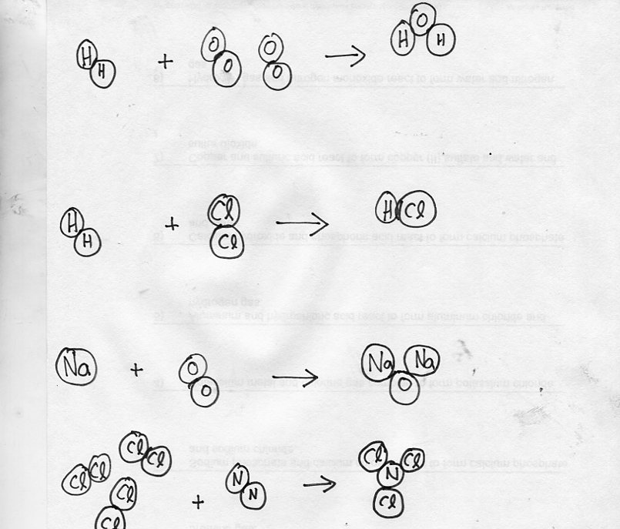

Don’t continue until you get a stamp here →
Write the unbalanced equations for the following chemical reaction.
Write formulas (like H₂O) and phases (like s, l, g, aq):

- When wax (C₂₂H₄₄ ) burns in oxygen, carbon dioxide, water and heat are produced.

Some of these are impossible because the mass of the Products is different from the mass of the Reactants.
If a reaction is possible, write POSSIBLE in the blank. Otherwise, write into the blank space what number of grams would make it possible.

- Hubba (16 grams) + Hubba (16 grams) → DoubleHub (30 grams) ___________
- Hiphip (3 grams) + Hooray (14 grams) → Cheer (17 grams) ___________
- Ping (1.5 grams) + Pong (38 grams) → Tick (17 grams) + Tock (22 grams)

- Some of the reactions above were impossible because the mass of the Products was different from the mass of the Reactants. This violated the Law of _________________________________________________.

Data and Observations. Don’t write anything into the blank until you draw a diagram that is similar to what you drew on the front.
- _____H2 + _____O2 → _____ H2O
Diagram:

- _____H2 + _____Cl2 → _____ HCl
Diagram:

Write the unbalanced equations for the following chemical reactions.
Write formulas (like H₂O)and phases (like s, l, g, aq):

- For the reaction Fe + Cl₂ -> FeCl₃ solve for the missing mass, using the law of conservation of mass in each case.
  - If 44 grams of iron react with 65 grams of chlorine, how much iron(III)chloride should form?

  - If 44 grams of iron react and 100 grams of iron(III)chloride form, how many grams of chlorine reacted?

Please go to Lab Data Blog at http:genest.weebly.com to submit a famous figure from Black History. I’ll give extra credit if we use your choice!

