iting reactions that obey the Law of Conservation of Mass  CλeMis+ry: http://genest.weebly.com  Stop in for help every day at lunch and Tues &Thurs after school! |  | Name_____________  Period_____________
Add more cartoon atoms until they obey the Law of Conservation of Mass
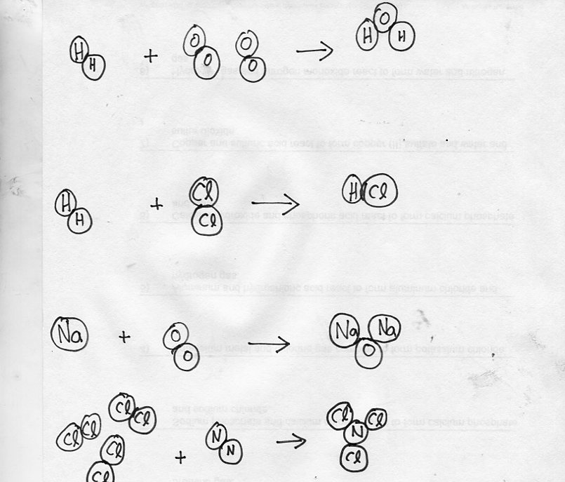
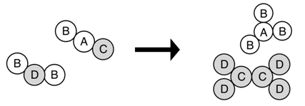
Don’t continue until you get a stamp here →

Rearranging Atoms
Data and Observations:
1. _____H2 + _____O2 → _____ H2O
Diagram:

2. _____H2 + _____Cl2 → _____ HCl
Diagram:

3. _____Na + _____O₂ → _____ Na2O
Diagram:

4. _____N2 + _____H2 → _____ NH3
Diagram:

5. _____CH4 + _____O2 → _____CO2 + _____H2O
Diagram:

