Heating Curves  CλeMis+ry: http://genest.weebly.com  Stop in for help every day at lunch and Tues, Weds., &Thurs after school!  After-hours question? Email me at home: eagenest@madison.k12.wi.us | 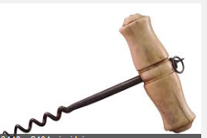 | Name_____________  Period_____________

- Label neatly on the graph of each of the following:
a. solid b. liquid c. Vapor/gas
d. melting point e. freezing point f. boiling point
g. condensation point h. melting i. freezing
j. vaporization k. condensation
l. first appearance of solid in heating
m. last appearance of solid in heating
n. first appearance of liquid in heating
o. last appearance of liquid in heating
p. first appearance of vapor in heating

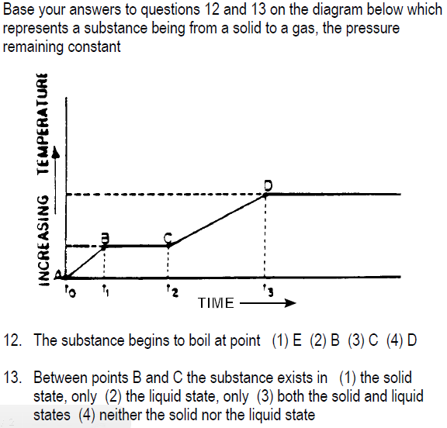

Directions: Read the caption and then sketch in an appropriate drawing you found between pages 268 to 279 of your textbook.

In both containers we see the same substance but the container on the right has a much greater vapor pressure.  What did the chemist do to the container on the right to cause more vapor pressure?  ___________________________________  ____________________________________ | This picture shows what would happen to a barometer if the atmospheric pressure was made less – it shows that the height of mercury changes in the tube  Question: What is inside the portion labeled vacuum?
In this drawing we see that pressure is caused by particles hitting the side of the container.  Question: Draw what would happen if the particles were heated to give them double the kinetic energy | This shows what the normal boiling point for water is.

