Writing Reactions From last Friday’s Quiz  CλeMis+ry: http://genest.weebly.com  Stop in for help every day at lunch and Tues &Thurs after school! | 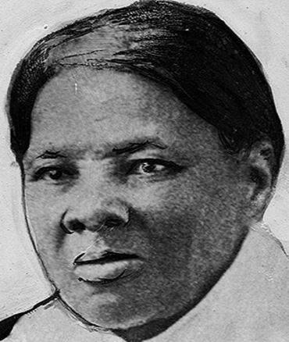 | Name_____________  Period_____________

Write an equation to describe each. Your answer will only be graded on having the correct formula and the correct phase (solid, liquid, etc). It does not need to obey the Law of conservation of Mass. It does not have to be ‘balanced’

- Magnesium chunks and chlorine gas react to make magnesium chloride powder.

- Ethane gas, C₂H₆ , reacts with oxygen gas to form carbon dioxide gas and water vapor.

- Copper(II) carbonate solution and sulfuric acid (H₂SO₄) solution react to make copper(II) sulfate solution, carbon dioxide bubbles and liquid water.

- Write either the names or formulas (your choice) of all of the REACTANTS shown in the TWO boxes above:

________________________________________________________________________________

- _____H2 + _____O2 → _____ H2O
Cartoon Diagram

- _____Na + _____O₂ → _____ Na2O
Cartoon Diagram

- _____H2 + _____Cl2 → _____ HCl

- _____CH4 + _____O2 → _____CO2 + _____H2O
Cartoon Diagram

