Balancing Reactions  CλeMis+ry: http://genest.weebly.com  Stop in for help every day at lunch and Tues &Thurs after school! | 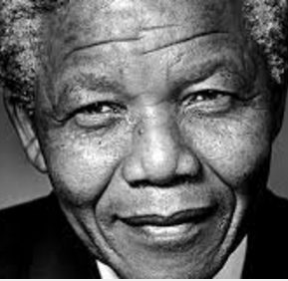  Nelson Mandela | Name_____________  Period_____________

How to turn an unbalanced equation into a balanced equation
- With your finger, point to one element before and the same element after the arrow. Whichever side has not enough, increase the coefficient (The Big Number – never never touch the small subscript numbers)
- write a little scoreboard. It helps. Grown up chemists do it all the time.
- Balance chemical formulas by placing coefficients in front of them. DO NOT add subscripts, because this will change the formulas.
Balance these!
- N_{2(g)} + H_{2(g)} NH_{3(g)} | draw a little scoreboard to keep track

- C₃H₈ + O₂ CO₂ + H₂O | draw a little scoreboard to keep track

- KClO₃ KCl + O₂ | draw a little scoreboard to keep track
balance each by writing coefficients in front of the compounds:
- CuO_{(s)} + C_{(s)} Cu_{(s)} + CO_{2(g)}

- C₃H₈ + O₂ CO₂ + H₂O

- NH_{3(g)} + O_{2(g)} NO_{(g)} + H₂O_{(l)}

- Which reaction numbers in #1 through #6 are combustion reactions? ______________

- Write a reaction that describes the combustion of CH₃OH. Balance it.
_______ + _______ →_______ + _______

- Which equation shows conservation of mass?  (1) H₂ + O₂ H₂O  (2) H₂ + O₂ 2H₂O  (3) 2H₂ + O₂ 2H₂O  (4) 2H₂ + 2O₂ 2H₂O | - If an equation is balanced properly, both sides of the equation must have the same number of  (1) atoms (2) coefficients (3) molecules (4) all of the above
8. Aqueous lead (IV) nitrate reacts with aqueous sodium sulfate to yield a lead (IV) sulfate precipitate and soluble sodium nitrate . Write a reaction and balance it.

- In the below reaction, draw a big box around the products. Draw a circle around the Reactants.
Fe(s) + O₂(g) Fe₂O₃(s)

- How many hydrogen atoms are present in each of these?
- _______ 5H₂O | - 9C₂H₂
- _______ (NH₄)₃PO₄ | - 2H₂SO₄

