Balancing Reactions  CλeMis+ry: http://genest.weebly.com  Stop in for help every day at lunch and Tues &Thurs after school! | 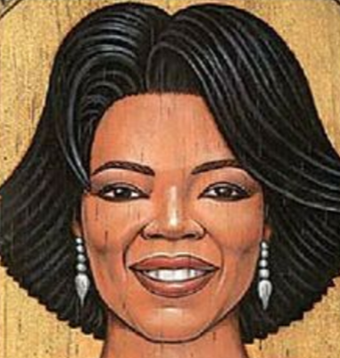 Oprah Winfrey | Name_____________  Period_____________

- What are the four substances are in a combustion reaction?
____________ + ____________ ____________ + ____________
- Write a balanced reaction for the combustion of C₂H₆
____________ + ____________ ____________ + ____________

- The box on the left shows the reactants of a combustion reaction. Make it a balanced reaction by drawing the products
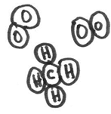  Reactants | → | Products

Balance each reaction by writing the smallest integers possible
- ___H₂ + ___Br₂ → ___HBr |  |  | - __CrBr₃ + __Na₂SiO₃ → __Cr₂(SiO₃)₃ + __NaBr
When placed in a test tube and ignited, iodine and aluminum give off bright light and produce a single substance.
Draw a cartoon of what would be in the test tube after the reaction finished.
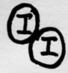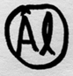  A test tube, with the reactants (five molecules) | → |  |  | The same test tube, with the reactants (two molecules)
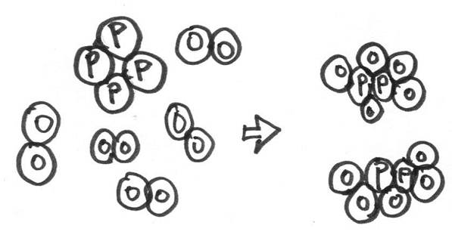  Inside a small box, Saturday |  | - Write a balanced reaction that describes what occurred inside the box shown to the left.
Same box, on Sunday

- Name each substance. Remember to use the back of your periodic table.
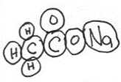  _______________ | 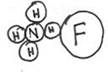  _______________ | 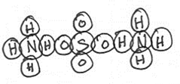  _______________ | This one needs a Roman numeral in its name!  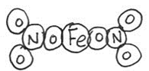  _______________

Balance each reaction by writing the smallest integers possible
- (NH₄)₂Cr₂O₇ → Cr₂O₃ + N₂ + H₂O  - KOH + Cl₂ → KCl + KClO + H₂O | - Ca(OH)₂ + H₃PO₄ → Ca₃(PO₄)₂ + H₂O  - Cu(NO₃)₂ → CuO + NO₂ + O₂

- Osmium is toxic; only try the following reactions on paper!
You want to know which reaction happens in lab:
first possibility: OsCl₂ + 2Li 1 Os + 2LiCl
second possibility: OsCl₃ + 3Li 1 Os + 3LiCl
And in the lab, your assistant measures that 0.411 moles LITHIUM reacts with 0.137 moles of LITHIUM.
- This ratio of $\frac{Li moles}{Os moles}$ is _______
- So the correct equation above is the (first/second) equation.

