Review #1 for Wednesday’s Test  VAHS Cλ3MIs+rγ  Mr. Genest |  | Name_________________  Date__________________  This is material for Test 5 – May 16
For Test 3 you should go re-do all homework we had since February 25. Go to the website to find it. The sheet you are holding will give practice in most of the types of math problems we solved.
- If you know the reaction AND you already know the ΔH…
- Do a railroad tracks style unit conversion
- You might need to convert grams to moles using the periodic table.
- For examples of this type of problem look on pages 304-306

- If you know the reaction but you need to find the ΔH … |  |  |  |  | - If hot water or another hot substance is gaining or losing heat and you know three of the four values for q, m, C, or ΔT
- Write a balanced reaction  - Look up the energies of each substance using a table of Standard Heat of Formation.  - Plug the table numbers into the following equation  ΔH = (ΔH of the products formation) – (ΔH of the reactants formation)  - Remember to multiply each energy by its coefficient in the balanced reaction. Be careful of all the double negative signs. To be safe, punch your answer into the calculator more than once to avoid careless goofs. |  |  |  |  | - Use your data to complete the equation q = m C ΔT  - For calculating metal dropped into water you should do one entire formula where all the letters are data for the water. Then do one entire formula where all the letters are data for the metal.
Use Method 1
For the reaction of  CaCl₂ + Na₂CO₃ CaCO₃ + 2NaCl ΔH = -360 kJ  3. Find how much heat is released when 9.2 moles of CaCl₂ react. | 4. Find how much heat is released when 100. grams of CaCl₂ react

Use Method 2

Use Method 3
Calculate the heat gained by the water.

For each change, circle either exothermic or endothermic. In each case, the system is underlined.
- You get into a parked car on July 10th and you sit on the hot car seat. (exothermic / endothermic )
- The oil in a bowl of burning oil (exothermic / endothermic )
- The air around a bowl of burning oil. (exothermic / endothermic )
- True story: a Verona teacher once poured an unlabeled beaker of chemicals into a drain. The water in the drain instantly boiled and shot out all over the teacher’s face, forcing them to run to the safety shower and spray their eyes. (exothermic / endothermic )
- Your hand if it is holding onto an ice cube. (exothermic / endothermic )
- A pancake is cooking on a griddle. You just turned off the stove and the pancake is still cooking. (exothermic / endothermic )
- In each pair circle the number which represents more energy;
    - 30,000 joules of heat energy vs 3 kilojoules of heat energy
    - 300,000 calories of energy vs 30,000 kilojoules of energy
- On game night, 52,000 people are in Tiger Stadium. By noon the next day there are only 200 people. Calculate the change in population. Describe the change with a bar graph. | 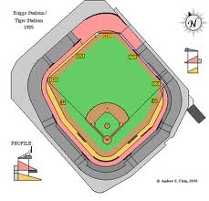 | Δpeople = (after - before)  Δpeople = (____ - _____)  Δpeople =

- If burning 4.50 grams of propane gas gives off 12,221 calories of heat to the room,
  - Is the change to room air exothermic or endothermic?

  - Calculate using railroad track conversions the number of kilojoules that would be given off by burning 61.00 grams of propane.

  - Calculate using railroad track conversions the number of kilograms of propane you would have to burn to give off 450. calories

- Assume that a student does an experiment by adding 52.2 grams of hot metal to a calorimeter of water. The before and after temperatures of the water are shown below as is the volume of water measured by the graduated cylinder.
How much heat entered the water?  How much heat left the metal? | 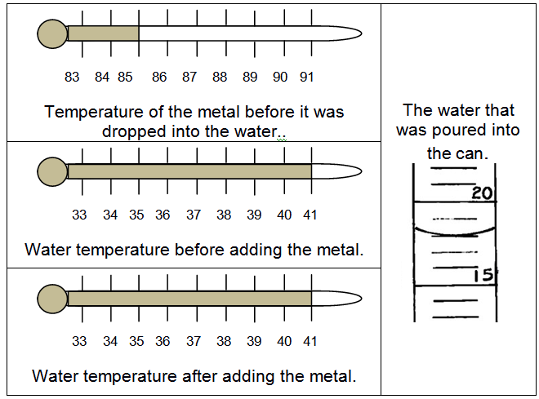 | Finally, calculate what the specific heat of the metal.

