Errors and Predicting Moles Yield  CλeMis+ry: http://genest.weebly.com  Stop in for help every day at lunch and Tues &Thurs after school! |  | Name_____________  Period_____________

Part 1: Solving a concentration problem in a single line.
It will often be helpful to set up our story problems using a single line calculation.

- A solution was mixed up that contained 344 grams of sodium chloride (table salt) per 1700 mL of aqueous solution. If a chemist took 6 squirts of this substance using a pipette that holds 1.3 mL and then she evaporated it in a crucible, how many grams of salt should she expect to obtain?

- A solution was mixed up that contained 40.6 grams of sodium chloride (table salt) per 568 mL of aqueous solution. If a chemist took 5 squirts of this substance using a pipette that holds 2.1 mL and then she evaporated it in a crucible, how many grams of salt should she expect to obtain?

Part 2: Deciding what effect an error has
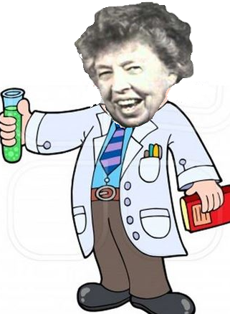 | Dr. Roosevelt mixed up some brine by stirring 429 grams of sodium chloride into enough water to make 788 mL of solution. She then took a clean 48.83 gram crucible filled and filled it by completely emptying a pipette 5 times into the crucible (a pipette that holds 1.2 mL). Heating this until all of the water evaporated resulted in a dry crust of salt in her crucible. Her cooled crucible, with salt, weighed 50.55 grams.
- Draw a picture or a table to organize your data from above.

- What mass of dry salt should she have recovered according to your theoretical calculations? (Set up your calculation in a single line if possible, like we did in class--it will make the next part much easier to solve.)

- Based on her scale readings, how many grams of salt did she actually recover?
- Did she recover more or less than was expected in a perfect experiment?

Look carefully at your answer for 5 and consider the following possibilities.

- During heating, tipping occurred, causing some brine solution to spill out from the crucible!
This would make her result accidentally (too small / still accurate / too large )!
- Heating stopped too soon. The stuff was still wet when it got weighed.
This would make her result accidentally (too small / still accurate / too large )!

- During the first weighing of the empty crucible, the scale wasn't tared (zeroed). The scale read 0.2 g even with nothing on it.
This would make her result accidentally (too small / still accurate / too large )!

- Popping and sputtering occurred and much liquid shot out during heating.
This would make her result accidentally (too small / still accurate / too large )!

- Two grams of sand from 1998 was stuck in the old crucible. It remained there for the entire experiment
This would make her result accidentally (too small / still accurate / too large )!

- The pipette, when you re-checked it, was actually a 0.9 mL pipette.
This would make her result accidentally (too small / still accurate / too large )!
Part 3: Predicting how many moles of product should form.
- How many moles of hydrogen gas will be produced if 2.5 moles of calcium hydride react according to the following equation?

CaH2 + 2 H2O → Ca(OH)2 + 2 H2

Before
Change
After

- How many moles of water will be produced if 0.45 mol of oxygen reacts according to the following equation?

2 C6H6 + 15 O2 → 12 CO2 + 6 H2O?

Before
Change
After

Part 4: How well did the results come out for some of the previous problems?

- If the chemist in Problem #1 on this homework actually obtained 1.4g of product, calculate their percent error.

- If the chemist in Problem #13 actually produced 5.2 moles of hydrogen gas, calculate percent error

- Calculate the percent error for Eleanor Roosevelts experiment in #4 and #5

