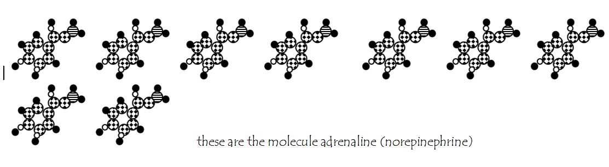

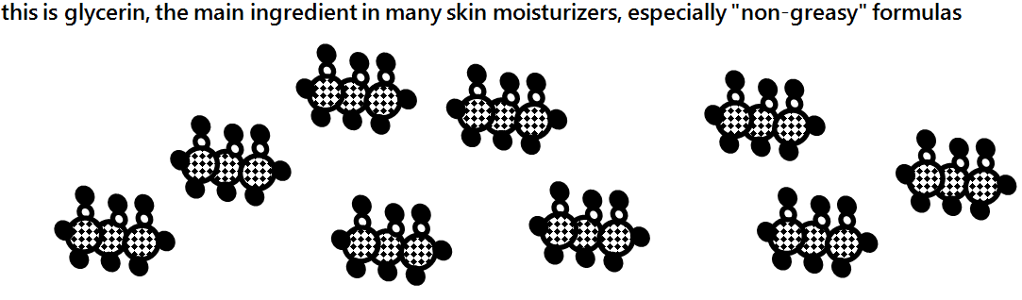

Warmup sheet: Keep and study  CλeMis+ry eagenest@madison.k12.wi.us |  | Name_____________________  Period____________________

How many moles of diskettes are taped to the tabletop?

Key to understanding the cartoons on this sheet:
1 chlorine atom | 1 hydrogen atom | 1 oxygen atom | 1 nitrogen atom | 1 carbon atom

How many moles of glycerine (skin moisturizer) are on the table?

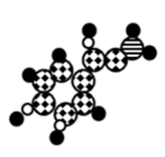 | How many moles of adrenaline are on the desktop?  What is the formula of adrenaline? (Use the key above.)  What is the mass of one mole of adrenaline? Use the periodic table and your formula.

