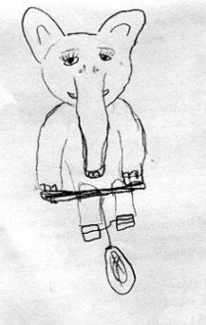 | Guid-  ed  Reading : Calor-  imetry  & Heat |  | Name___________________  Date____________________  Period_________________
Testable and Quizzable Ideas from the Blue Textbook Chapter 11. Be ready to hand this in.
Avoid pronouns.
Heat (p. 293, the the second paragraph)
- get the book’s definition of energy
Heat (p. 293, the last paragraph)
- Write at least four facts about heat
Heat Capacity (p. 296, the second paragraph)
- define heat capacity

Specific Heat Capacity (p. 297, the first paragraph)
- define specific heat capacity

The formula for heat (p. 297, the second paragraph)
- copy the formula
- label the parts of the formula in any way that will be useful for you to understand what the letters stand for.

A picture of a Calorimeter (p. 300, Figure 11.8)
- sketch and label the "SIMPLE CALORIMETER"
- From the caption, jot down the function of
  - the stirrer,
  - the thermometer, &
  - the chemical substances

Calorimetery (p. 300, the second paragraph)
- What two things are equal? (Super important***)

The sign of delta H (p. 301, the top)
- copy Table 11.3

Specific Heat (p. 296, Table 11.2)
- Try to find a pattern to what types of substances have low, medium, and high heat capacities

