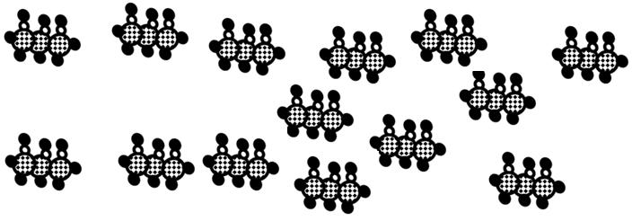

Warmup sheet: Keep and study  CλeMis+ry eagenest@madison.k12.wi.us |  | Name_____________________  Period____________________

Using your numbers from yesterday’s warmup sheet, calculate the mass, in grams, of the glycerine on the table top

Write a balanced reaction for the combustion of this substance

Calculate how many moles of carbon dioxide would form if you combusted the quantity of glycerine taped to the tabletop.

Key to understanding the cartoons on this sheet:
1 chlorine atom | 1 hydrogen atom | 1 oxygen atom | 1 nitrogen atom | 1 carbon atom

