how temperature of a gas affects its pressure  CλeMis+ry: http://genest.weebly.com  Stop in for help every day at lunch and Tues, Weds., &Thurs after school!  After-hours question? Email me at home: eagenest@madison.k12.wi.us | 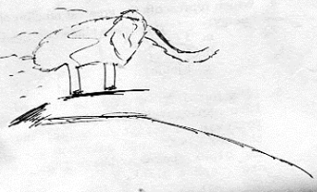 | Name_________  Period________

- If a tuna fish can is initially at 364 kelvins and initial pressure is 1.1 atm, what will the new pressure be if it is cooled to 300. kelvins?

- If you have a can that is at 2.0 atm and 293 kelvins, what temperature would make the pressure in the can be 1.0 atm?

More gas |  | Less Gas | - Total wall hits for  More gas: ______ Less Gas: ______  Compare the pressure in the two boxes using words like double, half, etc.:  _________________________  _________________________  _________________________  _________________________
Instructions: Draw 4 tiny particles. Using a ruler make each particle travel 30 cm |  | Instructions: Draw 2 tiny particles. Using a ruler make each particle travel 30 cm

More temperature |  | Less temperature | - Total wall hits for  High temperature: ______ Lower temperature: ______  Compare the pressure in the two boxes using words like double, half, etc.:  _________________________  _________________________  _________________________  _________________________
Instructions: Draw 4 tiny particles. Using a ruler make each particle travel 30 cm |  | Instructions: Draw 4 tiny particles. Using a ruler make each particle travel 15 cm

- When number of gas atoms increases, pressure will:
- When temperature of a gas increases, pressure will:
- When volume of a gas increases, pressure will:
- Label the X axis number of molecules and the Y axis pressure. Make a crude graph, without units.

- Based on the graph, pressure and molecule number are (directly / inversely) proportional.

- Label the X axis temperature and the Y axis pressure. Make a crude graph, without units.

- Based on the graph, pressure and temperature are (directly / inversely) proportional.

- Looking at the can in Problem #2 on the front of the sheet, calculate what the pressure would be if you reduced the temperature to “absolute zero”.

