- Weigh a solid chemical.  I have ________ grams of  ________ | - Pour water into any container.  I have _____ mL of water. | - Calculate.  I have ________ moles of the substance from (1) | - Calculate the concentration in “M” units

- Weigh the same solid chemical.  I have ________ grams of  ___________ | - Pour water into any container.  I have _____ mL of water. | - Calculate.  I have ________ moles of the substance from (1) | - Calculate the concentration in “M” units

Lab: Make two solutions 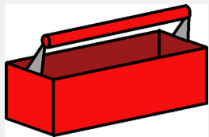 Name__________________________

of known* concentration
*We will see next week that our concentration is close but needs one more factor in the calculation.

Name the two substances used today using correct terminology from our notes from last week.
The solvent is _____________________________ The solute is _______________________________

Draw a macroscopic view of the two containers, clearly showing how dark each one is and how much volume is in it |  | Draw microscopic views of the two containers, clearly showing water and the solute.

