Energy Again  CλeMis+ry: http://genest.weebly.com  Stop in for help every day at lunch and Tues &Thurs after school! |  | Name_________  Period________

This should look familiar; you saw some of it in early March.
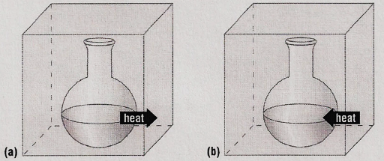
- Classify the following as exothermic or endothermic:
- __________________ 550 kJ is released
- __________________ The energy level of the products is higher than that of the reactants.
- __________________ The metabolism of glucose in the body provides energy.
- __________________ The energy level of the products is lower than that of the reactants.
- __________________ 125 kJ is absorbed

Energy in Chemical Reactions

- Classify the following as exothermic or endothermic reaction and give ΔH for each:
- Gas burning in a Bunsen burner: CH₄ + 2O₂ → CO₂ + 2H₂O + 890 kJ
- Dehydrating limestone: Ca(OH)₂ + 65.3 kJ → CaO + H₂O
- Formation of aluminum oxide and iron from aluminum and iron(III)oxide:
- 2Al + Fe₂O₃ → Al₂O₃ + 2Fe + 850 kJ
- Combustion of propane: C₃H₈ + 5O₂ → 3CO₂ + 4H₂O + 2200 kJ
- Formation of table salt: 2Na + Cl₂ → 2NaCl + 2H₂O + 819 kJ
- Decomposition of phosphorous pentachloride: PCl₅ + 67 kJ → PCl₃ + Cl₂

Watch and copy the solution.
- How much heat is released when 27.5 grams of CH₄ is combusted in oxygen?
CH_{4(g)} + 2O_{2(g)} CO_{2(g)} + 2H₂O_{(L)} ∆H = -890.4 kJ

Manual link for the video Thermochemical Equations Practice Problems
Tyler DeWitt https://www.youtube.com/watch?v=8m_FCe5aCq
Thermochemical Equations Practice Problems Click the link at genest.weebly.com

Watch only 0:00 to 4:45 !
- How much heat is released when 766 grams of CH₄ is combusted in oxygen?

- How much heat is released when 766 moles of CH₄ is combusted in oxygen? Note the unit is different!

Watch and copy the solution.
- How much heat is released when 79.2 grams of O₂ is combusted with excess methane?
CH_{4(g)} + 2O_{2(g)} CO_{2(g)} + 2H₂O_{(L)} ∆H = -890.4 kJ

Manual link for the video Thermochemical Equations Practice Problems
Tyler DeWitt https://www.youtube.com/watch?v=8m_FCe5aCq
Thermochemical Equations Practice Problems Click the link at genest.weebly.com

Watch only 4:45 to 7:48 !

- Now let’s try an endothermic reaction. How much heat is absorbed by a reaction where 138 grams of calcium hydroxide are turned into quicklime (CaO, used to make cement)? Use your periodic table and the coefficients from the following balanced equation:
Ca(OH)₂ → CaO + H₂O ∆H = + 65.3 kJ

- When 77.4 grams of sodium react, how much heat is given off?
2Na + Cl₂ → 2NaCl + 2H₂O ∆H = -819 kJ

