Review #2  CλeMis+ry: http://genest.weebly.com  Stop in for help every day at lunch and Tues &Thurs after school! | 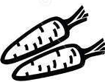 | Name_____________  Period_____________

- We know this energy diagram is wrong. Show three different ways that a single change could make it correct. |  | 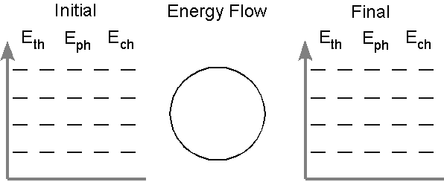

- 2 C10H22(g) + 31 O2(g) ---> 20 CO2(g) + 22 H2O(g) + 13483kJ
For the reaction above, which of these ratios are 'ONE'? In the box below each if the factor is true write True! if the factor is incorrect rewrite it so it isn't.
$$\frac{2 C10H22}{22.4 L C10H22}$$ |  | $$\frac{\begin{aligned}22.4 moles \\ O_{2} gas\end{aligned}}{1 liter O_{2}}$$ |  | $$\frac{31 mol O_{2}}{32 grams}$$ |  | $$\frac{1 mol H2O}{31 mol O_{2}}$$ |  | $$\frac{13485 kJ}{1 mol O_{2}}$$

- Suppose 2.00 L of nitrogen gas and 5.00 L of hydrogen gas are mixed and reacted to form ammonia (NH₃). Calculate the grams of ammonia produced when this reaction runs to completion.

- How many molecules are in 22.4 liters of steam?

- What is the molarity of solution made by dissolving 0.740 moles of NH₄Br in enough water to make 840. mL of solution?

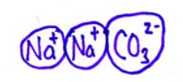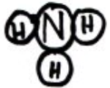
- What type of substance is each?
Na₂CO₃ is ( ionic / molecular )
NH₃ is ( ionic / molecular )
a) In the box, draw what two molecules of NH₃ would look like dissolved in some water molecules.

b) Draw two equations, including charges and phase subscripts, for each of these two substances above dissolving.
( for example, A_{(L)} -> B_{(aq)} )

- Which end of H₂O has which electrical charge? Circle a correct choice in each parenthetical pair. | 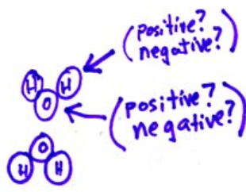

- Write an Energy Trace Diagram (LoL diagram) for the water in a wet t-shirt that is sitting on a clothesline.

- The center of Jupiter is believed to have such a high pressure that substances get compressed to very small volumes and change phase. Consider a burp from a cow being taken down to near the middle of Jupiter, where it changes to a solid substance under the extreme pressure. Write an Energy Trace Diagram (LoL diagram) for this.

- Write an Energy Trace Diagram (LoL diagram) for flour igniting in a candle flame.

- Write an Energy Trace Diagram (LoL diagram) for a can of beans on a stove, sealed, being heated until it explodes.

- Write an Energy Trace Diagram (LoL diagram) for a stick of dynamite going off.

