Review #1 (The test is Friday)  CλeMis+ry: http://genest.weebly.com  Stop in for help every day at lunch and Tues &Thurs after school! | 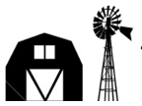 | Name_____________  Period_____________

- If you are working with a solution of 0.7M NaCl_{(aq)} which of these ratios are 'ONE'? In the box below each if the factor is true write True! if the factor is incorrect rewrite it so it isn't.
$$\frac{1 year}{365.25 days}$$ |  | $$\frac{\begin{aligned}22.4 moles \\ STP gas\end{aligned}}{1 mole STP gas}$$ |  | $$\frac{0.7 L}{1 mol Na+}$$ |  | $$\frac{1 inch}{12 feet}$$ |  | $$\frac{1 mol Cl}{\begin{aligned}6.02x{10}^{23} atoms \\ of chlorine ions\end{aligned}}$$

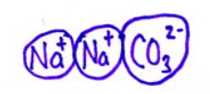
- This is a solid chunk of sodium carbonate.
- In the box draw an aqueous chunk of the same substance.
- Include eight water molecules.
- Make sure the waters are pointing in the right direction!

- Which end of H₂O has which electrical charge? Circle a correct choice in each parenthetical pair. | 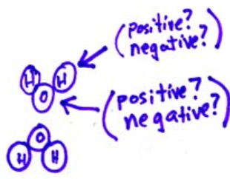

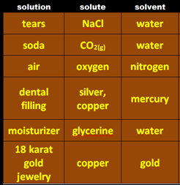
hint: you may have
this in you now
- Fill in the missing squares in the above table of solutes and solvents
- Things are facing in the wrong directions here. Think about ‘opposites attract’ and draw things facing correctly in the box.
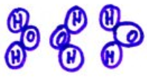

- From memory, what is the formula of each
carbonic acid _________________
phosphoric acid_______________

- Natural gas contains 97% methane (CH₄), 1.5% ethane (C₂H₆), 1% CO₂, and 0.5% nitrogen gases.

solvent ______________________

solute(s):

- Things are facing in the wrong directions here. Think about ‘opposites attract’ and draw things facing correctly in the box.
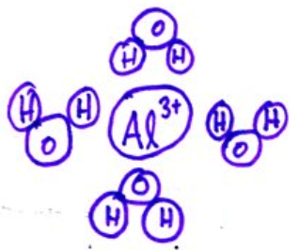

- Suppose an excess of aluminum was allowed to react with 45 mL of aqueous 0.39M hydrochloric acid to produce aluminum chloride and hydrogen gas. Assume the acid is the limiting reactant.
  - Write a balanced equation.

  - If all of the acid reacts, how many moles of aluminum should react?

  - If all of the acid reacts, how many grams of aluminum chloride will form?

  - If all of the acid reacts, how many liters, at STP, of hydrogen should form?

Determine the volume in liters of carbon dioxide that should be produced in the reaction between 98.0. g of carbon and 500. liters of O2. (Similar to the scissors sheet)

- What is the formula for finding volume if you’re given moles and concentration?

- Balance the equation shown here: ____ Pb(OH)₂ + ____ HCl ____ H₂O + ____ PbCl₂

- Based on the equation in the previous problema, if 45 mL of a 0.100M solution of Pb(OH)2 reacts, what volume of 0.740M HCl will react?

- Based on the equation in the previous problema, if 0.975L of a 0.050M solution of Pb(OH)2 reacts, what volume of 1.3M HCl will react?

- Balance the equation shown here: ____KOH(aq) + ____H₃PO₄(aq) → ____K₃PO₄(aq) + ____H₂O(l)

