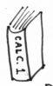
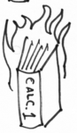
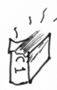
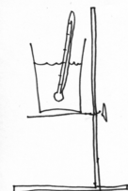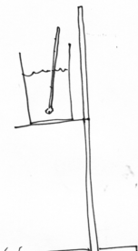

If the formula of ‘book’ is C₆H₁₂O₆, find how many moles of book burned | Recall that Cp for water is 4.18 J/g-°C  Q = m c_{p} ∆T  Find how many kilojoules went into the water
Use ratios to find how much heat would come out from burning 1 mole of book:

$$\frac{your joules}{your moles} = \frac{x}{1 mole}$$

2450. grams
of book
2050. grams
of book
200. mL water
21.0°C
27.0°C

