Unit 9 Lab: Volume of a Mole of Gas | Purpose  The purpose of this experiment is to determine the volume of a mole of gas at standard temperature and pressure.  Procedure  The pictures below will help you follow the discussion of the procedure.  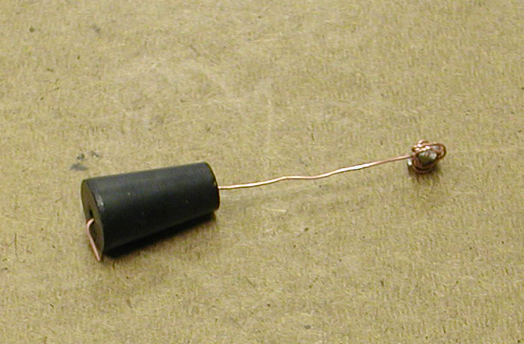  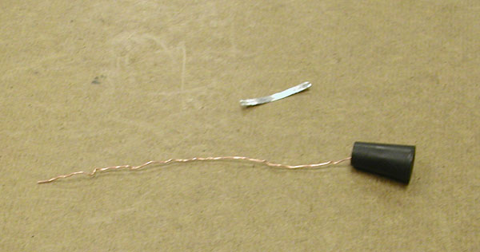  Fig 1 Strip of Mg ribbon,  stopper and copper wire.  Fig 2 The piece of Mg wrapped in a cage of copper wire.  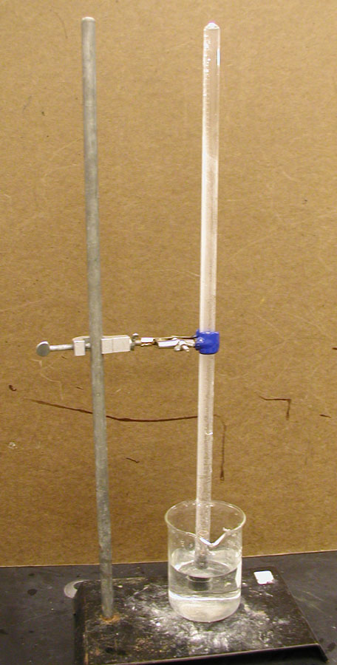  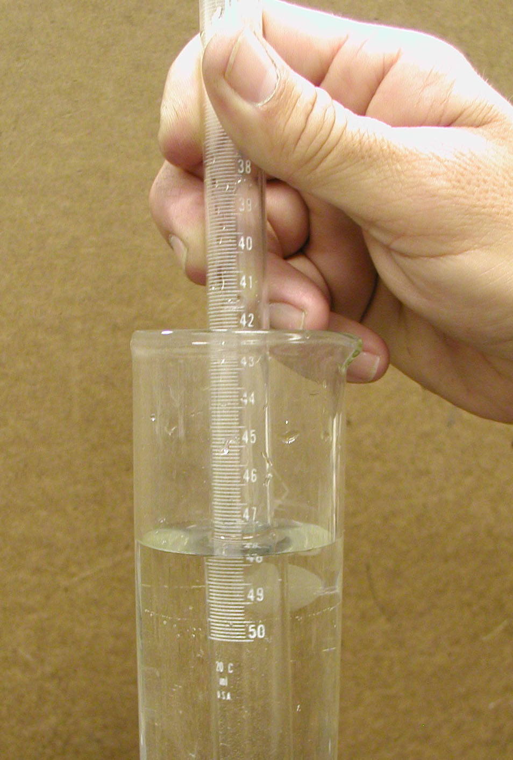  Fig 3 (left)  The gas measuring tube apparatus during the experiment.  Fig 4 (right)  Equalizing the pressure inside the tube and in the room.

Names.
write names of everyone in your group, yours first
everyone turns in their own sheet.

You must wear goggles. 1st violation, warning. 2nd, half off you and your partners lab

You must wear goggles. 1st violation, warning. 2nd, half off you and your partners lab

Data

Mass of 1.00 m of magnesium ribbon | g/m
Length of magnesium ribbon used | cm
Volume of gas collected | mL
Room temperature | ˚C
Room pressure (read barometer) | mm Hg
Vapor pressure of water | mm Hg

Calculations
1. The hydrogen gas collected also contains some water vapor. The pressure of this mixture of gases equals the room pressure. Find the partial pressure of H2 gas.

2. You collected H2 gas at room temperature and at the pressure you found in #1. Determine what the volume of gas would be at STP.

3. Determine the mass, then the moles of Mg used.

4. Write a balanced equation to describe the reaction between the Mg and HCl. Determine the number of moles of H2 gas in your sample.

5. Determine the volume of one mole of H2 gas at STP.

6. Determine the % error in your experimental value.
needs revision

7. Consider the model we have developed to represent molecules of a gas at room temperature. You may remember that the volume of a gas is roughly 1000x as great as that of a liquid. With this in mind, predict the volume of a mole of another gas, say N2 or CO2, at STP. Justify your prediction.

